Amazon Pay

**Version** 19.1.0



Table of Contents

1. Summary 4

2. Component Overview 5

2.1. Functional Overview 5

2.2. Use Cases 5

1. Confirmed Order in One Step Checkout 6

2. Authorized Charge in One Step Checkout 11

3. Declined Charge in One Step Checkout 15

4. Authorized Capture in One Step Checkout 17

5. Declined Capture in One Step Checkout 18

6. Confirmed Order in SFRA Checkout 20

7. Authorized Charge in SFRA Checkout 25

8. Declined Charge in SFRA Checkout 30

9. Authorized with Capture in SFRA Checkout 34

10. Declined Capture in SFRA Checkout 37

2.3. Limitations, Constraints 40

2.4. Compatibility 40

2.5. Privacy, Payment 41

3. Implementation Guide 41

3.1. Amazon Pay Cartridge Components 41

3.2. Setup 43

3.3. Configuration 44

3.3.1. Assign the Cartridge to the Site 44

3.3.2. Import Metadata 44

3.3.3. Configure Amazon Pay Site Preferences 45

3.4. Custom Code 51

3.4.1. Controllers 51

3.4.2. Scripts 54

3.4.3. Template Modifications 55

3.5. Testing 62

3.5.1. APN 62

3.5.2. IPN 65

4. Operations, Maintenance 71

4.1. Data Storage 71

4.2. Availability 71

4.3. Support 71

5. User Guide 71

5.1. Roles, Responsibilities 71

5.2. Business Manager 71

5.3. Storefront Functionality 71

6. Known Issues 71

7. FAQ 72

8. Release History 72

# Summary

The Amazon Pay cartridge is a self-contained cartridge that provides rapid integration for a Salesforce Commerce Cloud implementation. The Amazon Pay cartridge extends Storefront Reference Architecture functionality by allowing merchants to enhance and configure the checkout flow based on Amazon Pay features and allows users to use the addresses and the payment methods available in their Amazon accounts. Customers don’t have to enter address and payment information to complete their orders, thus increasing the likelihood of conversion.

Amazon Pay Cartridge helps merchants identify customers when they login with Amazon by receiving the customer’s name and email address.

The installation is done in Business Manager and the installation steps will be detailed in this document.

# Component Overview

## Functional Overview

The Amazon Pay cartridge is aimed for merchants based in three regions:

-North America, for United States;

-Europe, for United Kingdom, Germany, Italy, Spain, France;

-Asia, for Japan.

The cartridge allows Salesforce Commerce Cloud customers to complete the checkout process using their Amazon accounts. During the checkout process, customers will have the option to log in to their Amazon account and use the shipping and payment information saved in their Amazon account without re-entering all the information necessary on the Salesforce Commerce Cloud website.

The main features of the cartridge are:

* **Business Manager Configuration Page with Site Preferences**: the cartridge can be configured through a custom group site preferences group in Business Manager.
* **Login and Pay with Amazon Pay**: implementation allows user to log in into their Amazon accounts and choose shipping address and payment method.
* **Instant Payment Notifications**: the cartridge has an implementation to receive and handle Instant Payment Notifications from Amazon Pay when the site URL is configured in Amazon’s Seller Central.
* **Action Payment Notifications**: the cartridge has an implementation to receive request from 3rd parties that has the token to send requests to Authorize, Charge or Refund the buyer. In the requests is necessary to send the Charge Permission Id connected to the Order and the Action.
* **Email notification when using APN**: the cartridge allows setting up the emails for Authorize, Charge and Refund order notification. Merchant can design the templates present in cartridge as desired.
* **Responsive Design Support**: the Amazon hosted pages adapt to mobile design seamlessly.
* **Checkout types**: the cartridge allows merchants two checkout experiences, the SFRA checkout and a one step checkout experience.

## Use Cases

Amazon Pay cartridge impacts the checkout flow. The flow can be either a *One Step Checkout* or the *SFRA Checkout*.

The main functionalities are present in both versions, the main difference between them is that the *One Step* *Checkout* provides a faster purchasing experience, the checkout experience being reduced from 3 steps, to one step checkout page, thus improving the user experience.

Registered and unregistered customers will be able to follow the One Step Checkout and SFRA Checkout flows with following changes:

For both, registered and unregistered customers, in either checkouts they will follow the same experience, the difference for customers already registered in the SFCC site is that their orders will be associated with their Profiles. With that they can track their orders.

If any problems will occur, the Amazon Pay system will return an error. The errors could be reviewed on the Logs section in Business Manager Administration.

In this Use Cases section, it’s covered the following points:

* Registered/Unregistered SFCC Customers
* One Step Checkout/SFRA Checkout
* Payment Intent – Authorize/Confirm/Authorized with Capture
* Payment Authorization: Authorized/Declined/Canceled

The use cases will contain entries and steps for each. Entries will correspond to the Charge state given in by Amazon Pay system and to the site preferences needed to reproduce the use case, and they are Checkout Type and Payment Intent.

### Confirmed Order in One Step Checkout

This use case is to confirm the order details without authorizing and charging the buyer. So, the Merchant will give more time to Amazon Pay to analyze and determine the validity of payment.

It’s important to notice that in this use case there will be needed to have 3rd party system to handle programmatically the incoming orders, so calling the endpoint present in the cartridge (APN) to Authorize, to Charge and to Refund the buyer.

Entries

|  |  |
| --- | --- |
| Site Preference **Payment Intent:** | Confirm |

* 1. Customer adds product to Cart.

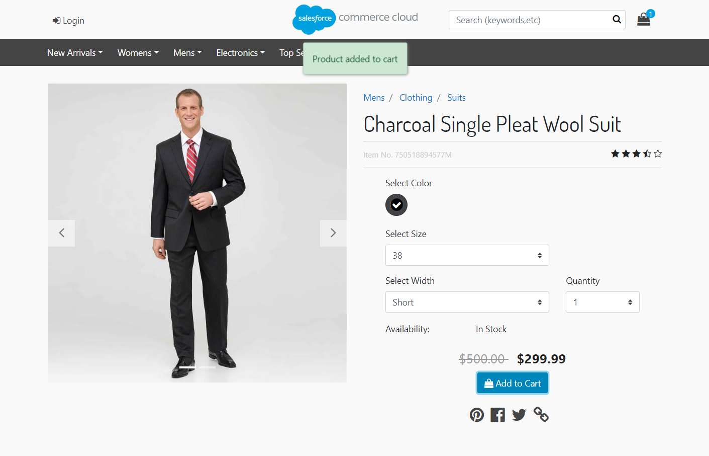

* 1. *Alternative flows:*
     1. Customer hovers over the Cart icon showing up the Mini Cart page, then click the Checkout Button.

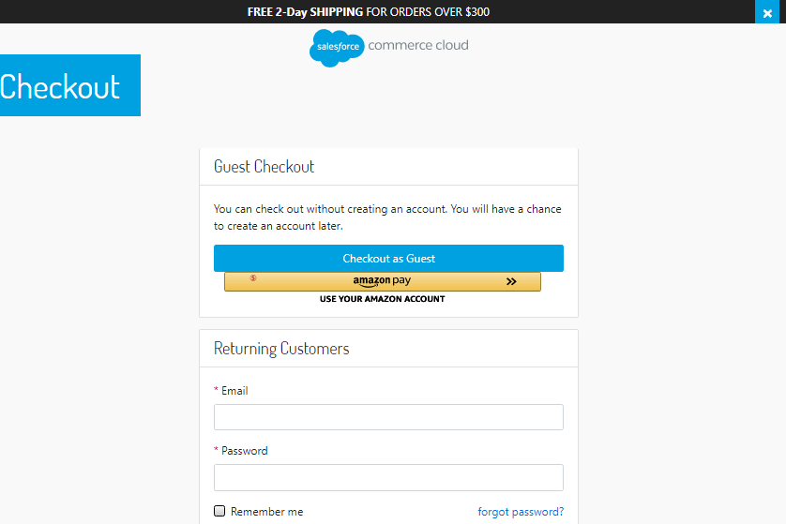

* + 1. Customer hovers the Cart icon showing up the Mini Cart page, then clicks on the Cart link and is redirected to the Cart page.

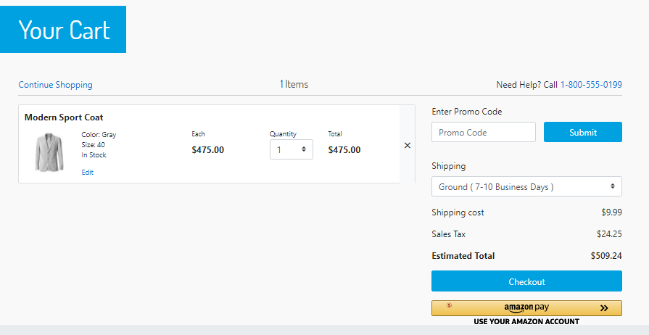

* 1. Customer clicks *Amazon Pay* button then it’s redirected to the Amazon Pay hosted page.
  2. Customer logs in with their Amazon account.

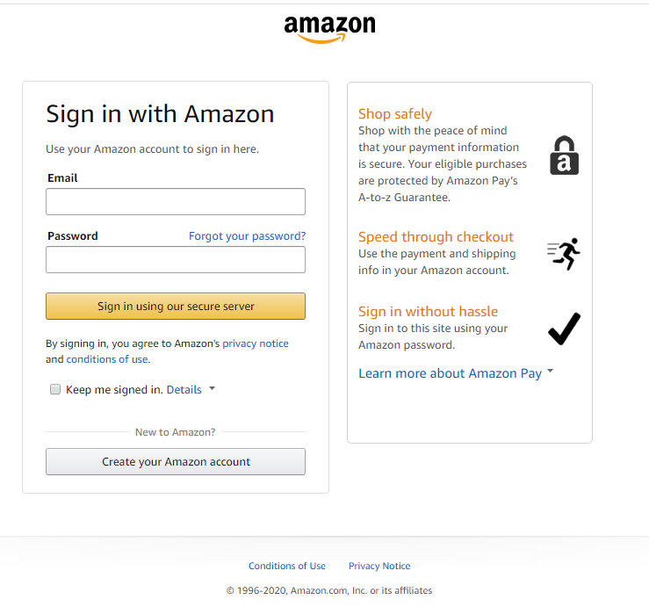

* 1. After selecting shipping address and payment method, customer clicks the button ***Continue to checkout***.

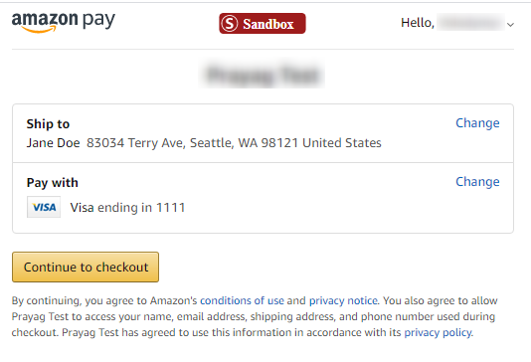

* 1. Customer is redirected back to the SFCC checkout page and clicks the button ***Place Order***.

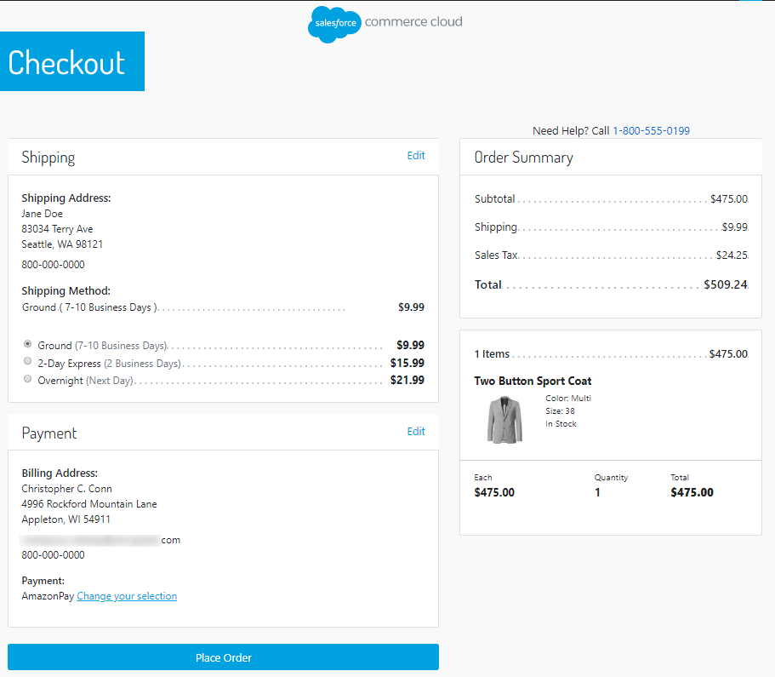

* 1. Customer is redirected to the Processing payment Amazon Pay hosted page.

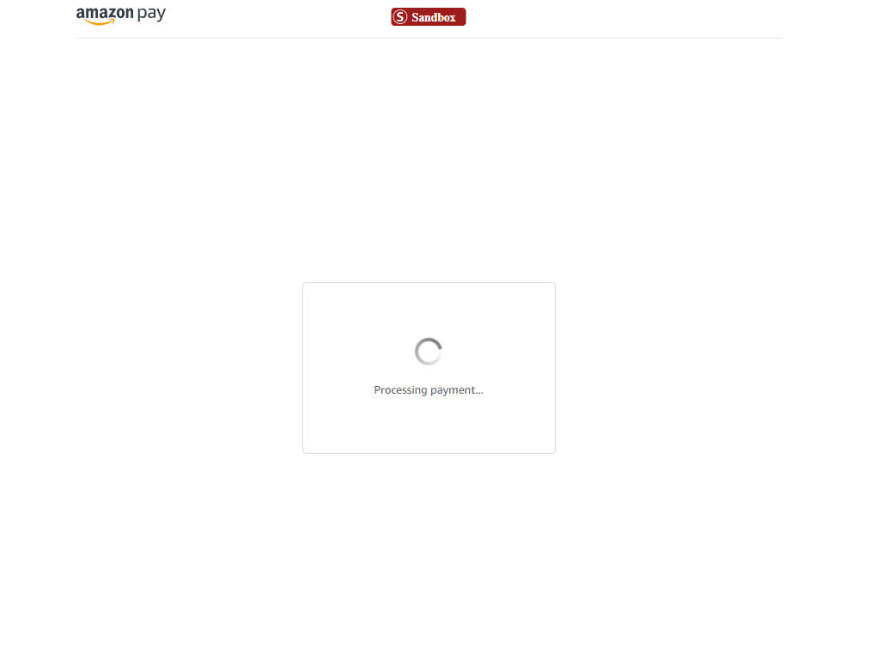

* 1. An order is created.
  2. If the customer has an account already created the order will be connected to his account. If not, the order will not be connected to any customer account.
  3. If Checkout Session status is:
     1. **Canceled**: Order will be failed with the status of **Failed**.
     2. **Completed**: Order will be placed with the status of **New**.
  4. Depending on the previous step the buyer is redirected to:
     1. **Completed**: Order confirmation page with the order details.

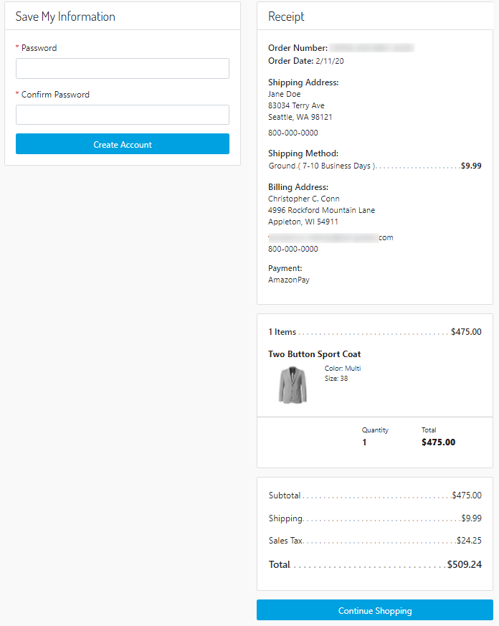

* + 1. **Canceled**: Cart page with a message for the payment decline.

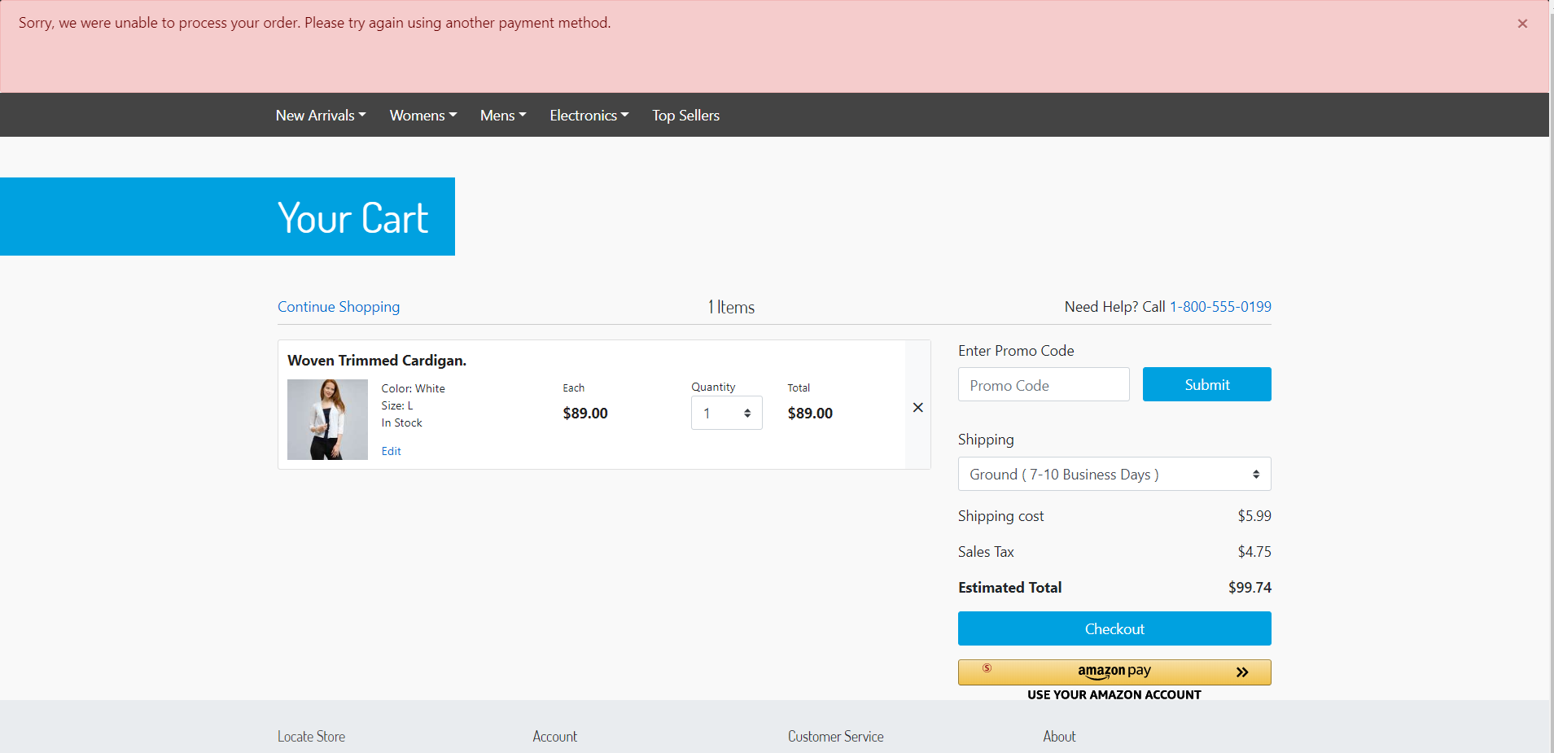

* 1. Buyer will receive an email from Amazon Pay about the processing payment.

### Authorized Charge in One Step Checkout

Entries

|  |  |
| --- | --- |
| **Customer Type:** | Registered/Unregistered |
| Site Preference **Payment Intent:** | Authorize |
| Amazon responses with **Authorization Result:** | Authorized |

* 1. Customer adds product to Cart.



* 1. *Alternative flows:*
     1. Customer hovers the Cart icon showing up the Mini Cart page, then click the Checkout Button.



* + 1. Customer hovers the Cart icon showing up the Mini Cart page, then clicks on the Cart link and is redirected to the Cart page.



* 1. Customer clicks *Amazon Pay* button then it’s redirected to the Amazon Pay hosted page.
  2. Customer logs in with his Amazon account.

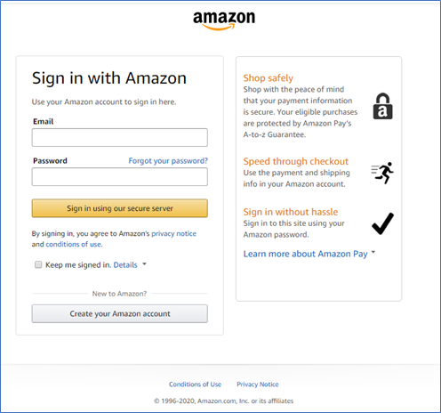

* 1. After selecting shipping address and payment method, customer clicks the button ***Continue to checkout***.



* 1. Customer clicks the button ***Place Order***.



* 1. Customer is redirected to the Processing payment Amazon Pay hosted page.

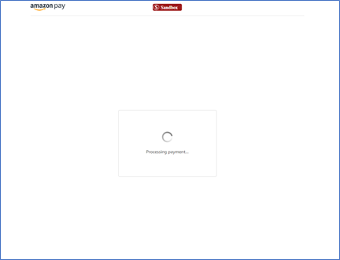

* 1. The Charge is **Authorized**, and the ***buyer can be charged***.
  2. An order is created and placed not being related/connected to any Customer Account and its status will be **New**.
  3. Customer is redirected to the Order confirmation page with the order details.



### Declined Charge in One Step Checkout

Entries

|  |  |
| --- | --- |
| **Customer Type:** | Registered/Unregistered |
| Site Preference **Payment Intent:** | Authorize |
| Amazon responses with **Authorization Result:** | Declined |

* 1. Customer adds product to Cart.
  2. *Alternative flows:*
     1. Customer hovers the Cart icon showing up the Mini Cart page, then click the Checkout Button.
     2. Customer hovers the Cart icon showing up the Mini Cart page, then clicks on the Cart link and is redirected to the Cart page.
  3. Customer clicks *Amazon Pay* button then it’s redirected to the Amazon Pay hosted page.
  4. After selecting shipping address and payment method, customer clicks the button ***Continue to checkout***.

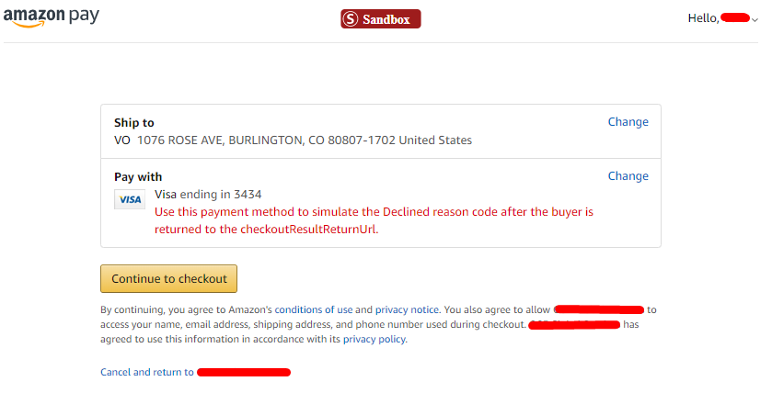

* 1. Customer clicks the button ***Place Order***.



* 1. Customer is redirected to the Processing payment Amazon Pay hosted page. The Charge is **Declined**, and the ***buyer can not be charged***.
  2. An order is created and placed not being related/connected to any customer account and its status will be **Failed**.
  3. Customer is redirected to the Cart page that will show a message for the failed payment attempt.

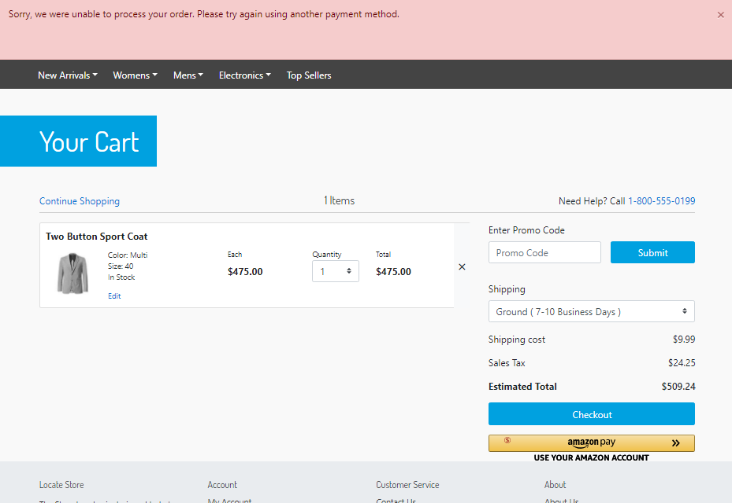

### Authorized Capture in One Step Checkout

Entries

|  |  |
| --- | --- |
| **Customer Type:** | Registered/Unregistered |
| Site Preference **Payment Intent:** | Authorized with Capture |
| Amazon responses with **Authorization Result:** | Authorized |

* 1. Customer adds product to Cart.
  2. *Alternative flows:*
     1. Customer hovers the Cart icon showing up the Mini Cart page, then click the Checkout Button.
     2. Customer hovers the Cart icon showing up the Mini Cart page, then clicks on the Cart link and is redirected to the Cart page.
  3. User clicks *Amazon Pay* button then it’s redirected to the Amazon Pay hosted page.
  4. After selecting shipping address and payment method, customer clicks the button ***Continue to checkout***.
  5. Customer clicks the button ***Place Order***.



* 1. Customer is redirected to the Processing payment Amazon Pay hosted page.
  2. The Charge is **Authorized**, and the ***buyer can be charged***.
  3. An order is created and its status will be **New**.
  4. *Alternative flows*:
     1. If Charge was captured successfully, the order is placed and customer is redirected to the Order confirmation page with the order details. The order is Paid and captured.
     2. If Charge was not captured successfully, the order placed and customer is redirected to the Order confirmation page with the order details. The order is Not Paid and not captured.

### Declined Capture in One Step Checkout

Entries

|  |  |
| --- | --- |
| **Customer Type:** | Registered/Unregistered |
| Site Preference **Payment Intent:** | Authorized with Capture |
| Amazon responses with **Authorization Result:** | Declined |

* 1. Customer adds product to Cart.
  2. *Alternative flows:*
     1. Customer hovers the Cart icon showing up the Mini Cart page, then click the Checkout Button.
     2. Customer hovers the Cart icon showing up the Mini Cart page, then clicks on the Cart link and is redirected to the Cart page.
  3. User clicks *Amazon Pay* button then it’s redirected to the Amazon Pay hosted page.
  4. After selecting shipping address and payment method, customer clicks the button ***Continue to checkout*** and is brought back to the Checkout - Summary page.

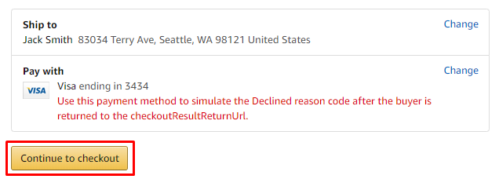

* 1. Customer clicks the button ***Place Order***.
  2. Customer is redirected to the Processing payment Amazon Pay hosted page.



* 1. The Charge is **Declined**, and the ***buyer can not be charged***.
  2. An order is created and failed not being related/connected to any customer account and its status will be **Failed**.
  3. Customer is redirected to the Cart page that will show a message for the failed payment attempt.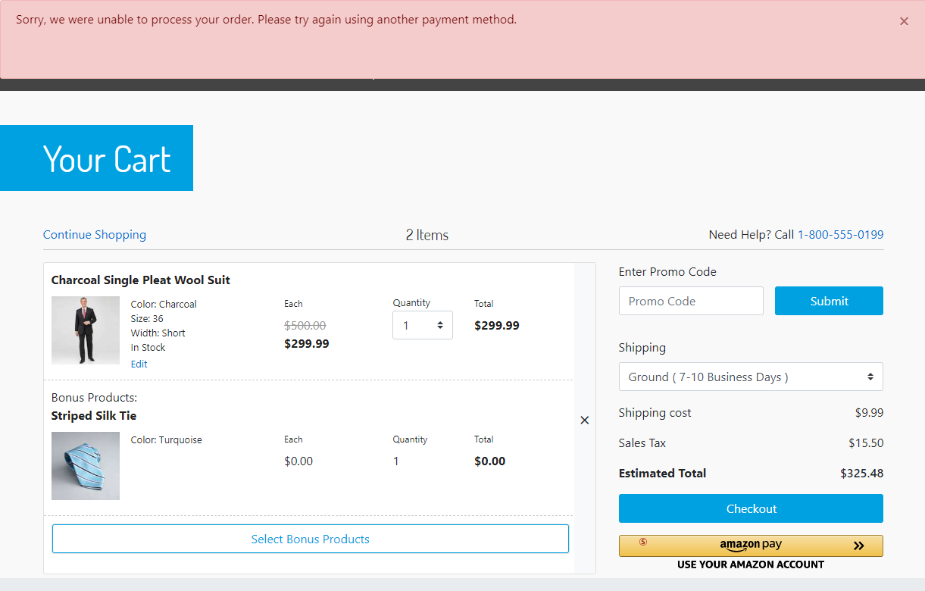

### Confirmed Order in SFRA Checkout

This use case is to confirm the order details without authorizing and charging the buyer. So, the Merchant will give more time to Amazon Pay to analyze and determine the validity of payment.

It’s important to notice that in this use case there will be needed to have 3rd party system to handle programmatically the incoming orders, so calling the endpoint present in the cartridge (APN) to Authorize, to Charge and to Refund the buyer.

Entries

|  |  |
| --- | --- |
| Site Preference **Payment Intent:** | Confirm |

* 1. Customer adds product to Cart.

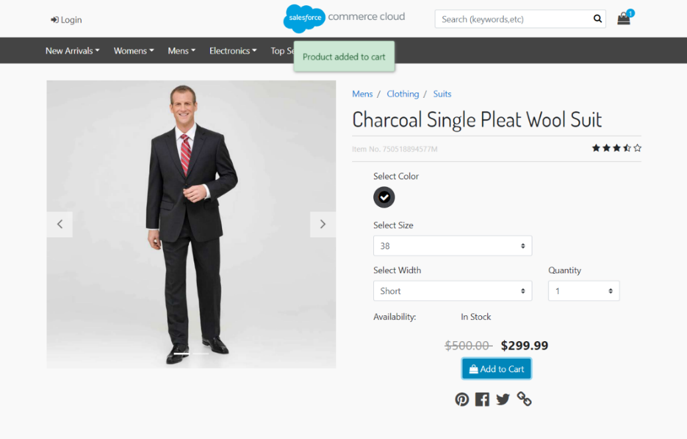

* 1. *Alternative flows:*
     1. Customer hovers the Cart icon showing up the Mini Cart page, then click the Checkout Button.



* + 1. Customer hovers the Cart icon showing up the Mini Cart page, then clicks on the Cart link and is redirected to the Cart page.



* 1. Customer clicks *Amazon Pay* button then it’s redirected to the Amazon Pay hosted page.
  2. Customer logs in with his Amazon account.



* 1. After selecting shipping address and payment method, customer clicks the button ***Continue to checkout***.



* 1. Customer is redirected back to the SFCC checkout page and reviews the shipping address with the fields as read only. Then he clicks the button *Next: Payment*.

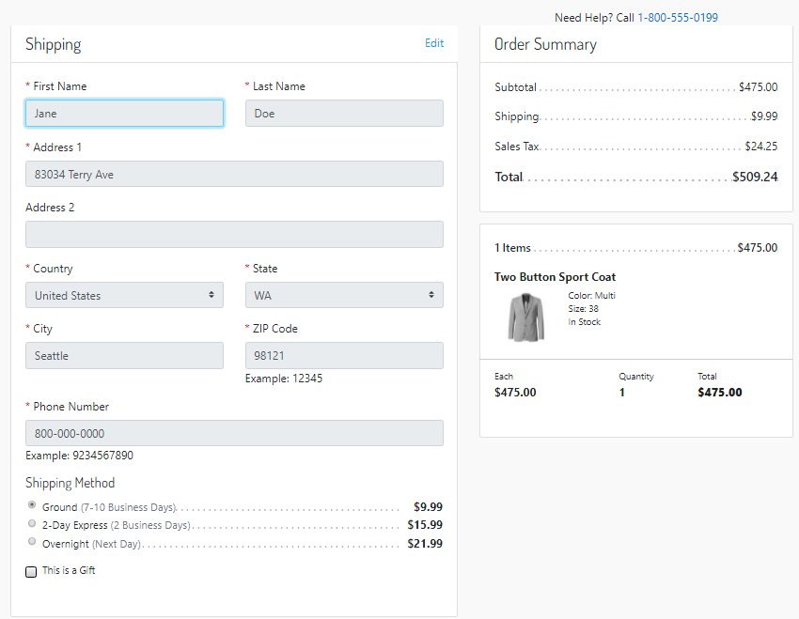

* 1. After clicking button ***Next: Payment****,* customer is on the Payment step and he can edit or add new billing address.

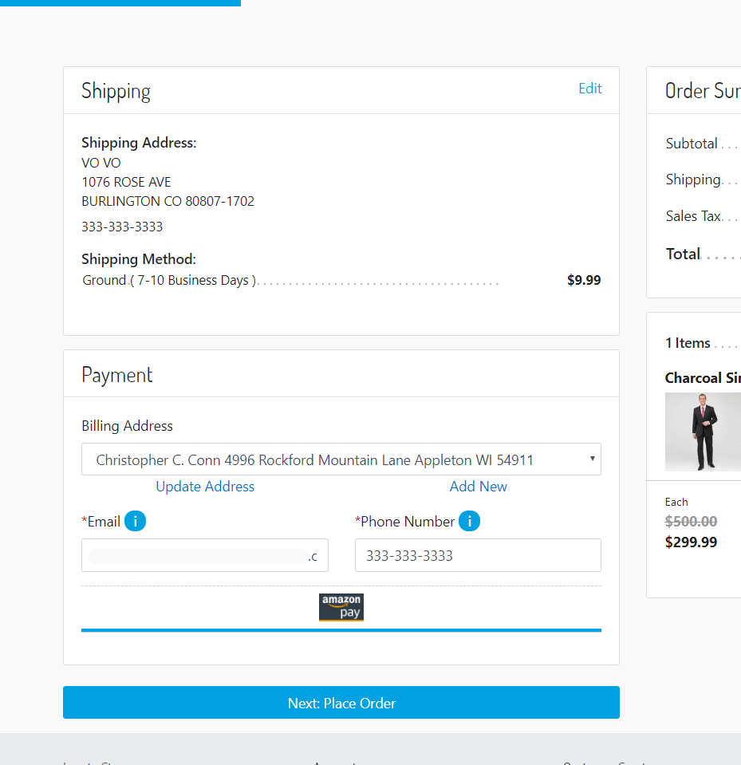

* 1. After customer clicked the button ***Next: Place Order*** will be in the review page.

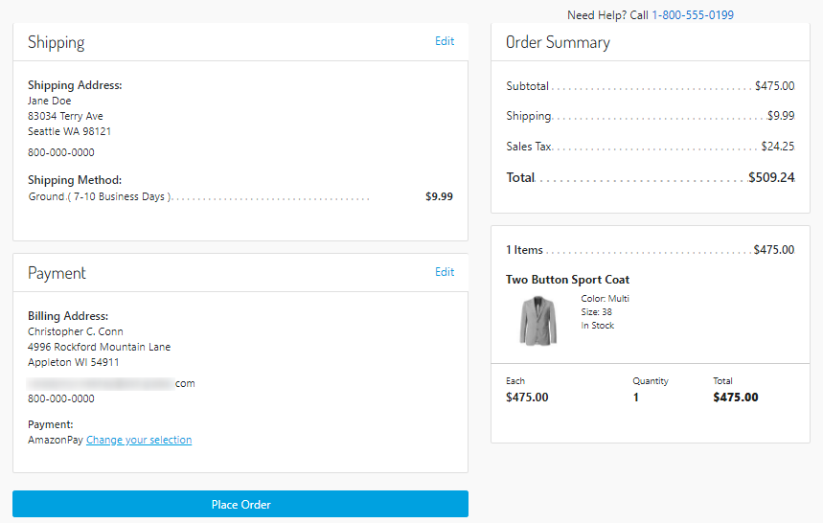

* 1. Customer clicks button **Place Order**.
  2. Customer is redirected to the Processing payment Amazon Pay hosted page.



* 1. An order is created.
  2. If customer has an account already created in SFCC site, the order will be associated to his profile.
  3. If Checkout Session status is:
     1. **Canceled**: Order will be failed with the status of **Failed**.
     2. **Completed**: Order will be placed with the status of **New**.
  4. Depending of the previous step the buyer is redirected to:
     1. **Completed**: Order confirmation page with the order details.

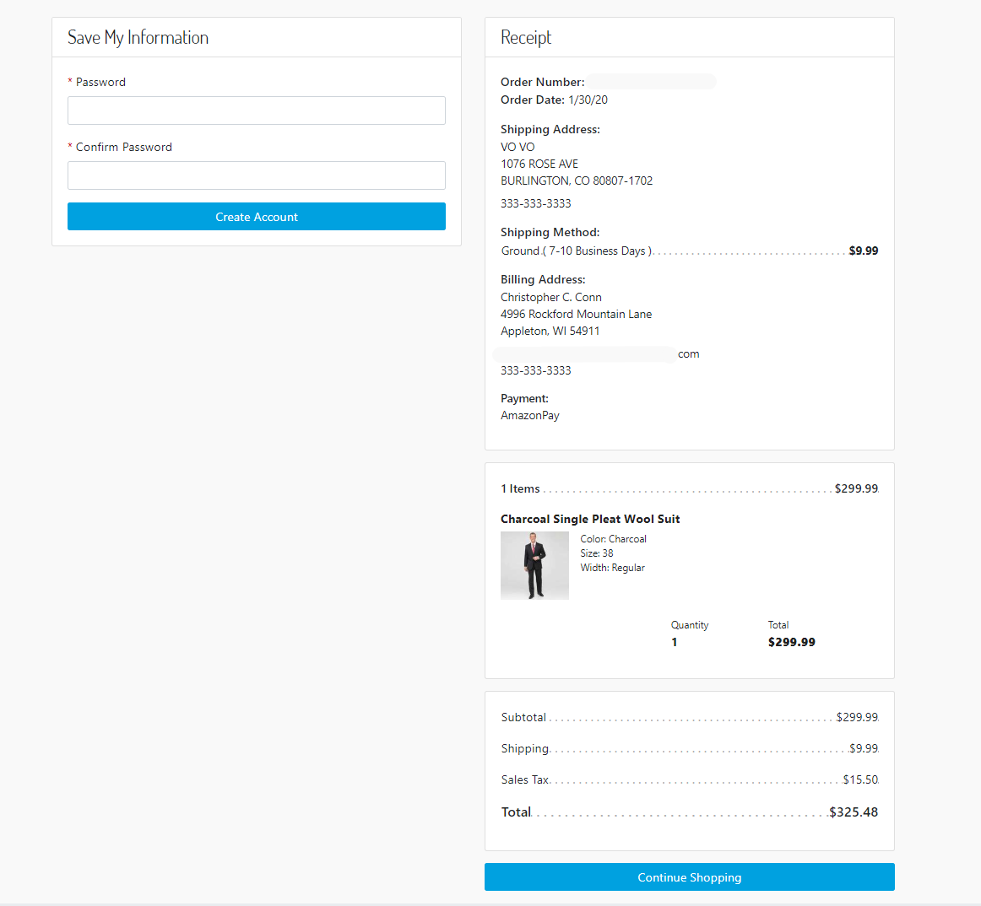

* + 1. **Canceled**: Cart page with a message for the payment decline.



* 1. Buyer will receive an email from Amazon Pay about the processing payment.

### Authorized Charge in SFRA Checkout

Entries

|  |  |
| --- | --- |
| **Customer Type:** | Registered/Unregistered |
| Site Preference **Payment Intent:** | Authorize |
| Amazon responses with **Authorization Result:** | Authorized |

* 1. Customer adds product to Cart.
  2. *Alternative flows:*
     1. Customer hovers the Cart icon showing up the Mini Cart page, then click the Checkout Button.

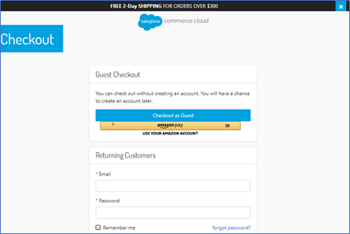

* + 1. Customer hovers the Cart icon showing up the Mini Cart page, then clicks on the Cart link and is redirected to the Cart page.



* 1. Customer clicks ***Amazon Pay* button** then it’s redirected to the Amazon Pay hosted page.
  2. Customer logs in with his Amazon account.



* 1. After selecting shipping address and payment method, customer clicks the button ***Continue to checkout***.



* 1. Customer is redirected back to the SFCC checkout page and reviews the shipping address with the fields as read only. Then he clicks the button *Next: Payment*.



* 1. After clicking button ***Next: Payment****,* customer is on the Payment step and he can edit or add new billing address.

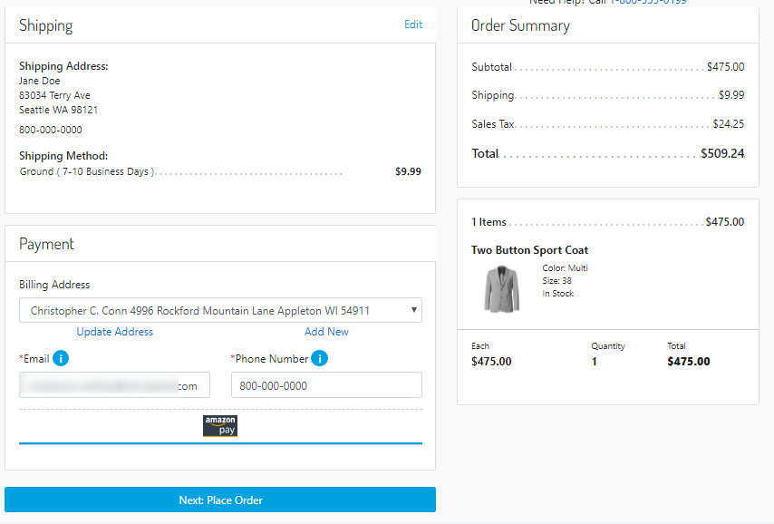

* 1. After customer clicked the button ***Next: Place Order*** will be in the review page.



* 1. Customer clicks button **Place Order**.
  2. Customer is redirected to the Processing payment Amazon Pay hosted page.



* 1. The Charge is **Authorized**, and the ***buyer can be charged***.
  2. An order is created and its status will be **New**.
  3. *Alternative flows*:
     1. If customer has an account already created in SFCC site, the order will be associated to his profile.
     2. If customer has not an account already created in SFCC site, the order will not be associated to any customer profile.
  4. Customer is redirected to the Order confirmation page with the order details.

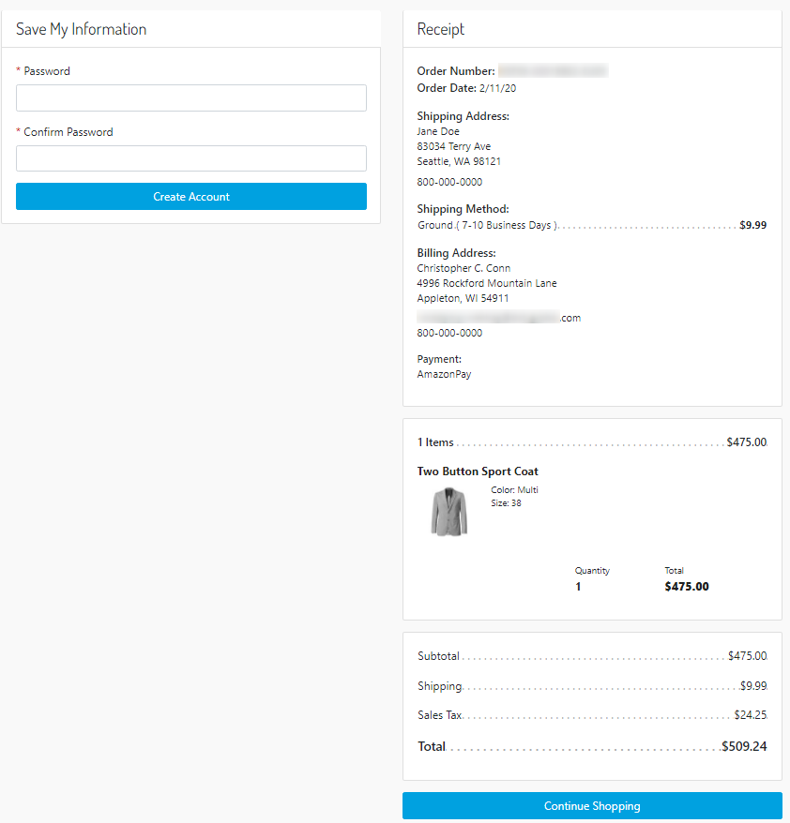

### Declined Charge in SFRA Checkout

Entries

|  |  |
| --- | --- |
| **Customer Type:** | Registered/Unregistered |
| Site Preference **Payment Intent:** | Authorize |
| Amazon responses with **Authorization Result:** | Declined |

* 1. Customer adds product to Cart.
  2. *Alternative flows:*
     1. Customer hovers the Cart icon showing up the Mini Cart page, then click the Checkout Button.



* + 1. Customer hovers the Cart icon showing up the Mini Cart page, then clicks on the Cart link and is redirected to the Cart page.

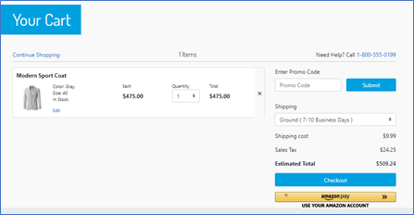

* 1. Customer clicks *Amazon Pay* button then it’s redirected to the Amazon Pay hosted page.
  2. After selecting shipping address and payment method, customer clicks the button ***Continue to checkout***.



* 1. Customer is redirected back to the SFCC checkout page and reviews the shipping address with the fields as read only. Then he clicks the button *Next: Payment*.



* 1. After clicking button ***Next: Payment****,* customer is on the Payment step and he can edit or add new billing address.



* 1. After customer clicked the button ***Next: Place Order*** will be in the review page.



* 1. Customer clicks button ***Place Order***.
  2. Customer is redirected to the Processing payment Amazon Pay hosted page. The Charge is **Declined**, and the ***buyer can be charged***.
  3. An order is created and placed not being related/connected to any customer account and its status will be **Failed**.
  4. Customer is redirected to the Cart page that will show a message for the failed payment attempt.



### Authorized with Capture in SFRA Checkout

Entries

|  |  |
| --- | --- |
| **Customer Type:** | Registered/Unregistered |
| Site Preference **Payment Intent:** | Authorized with Capture |
| Amazon responses with **Authorization Result:** | Authorized |

* 1. Customer adds product to Cart.
  2. *Alternative flows:*
     1. Customer hovers the Cart icon showing up the Mini Cart page, then click the Checkout Button.
     2. Customer hovers the Cart icon showing up the Mini Cart page, then clicks on the Cart link and is redirected to the Cart page.
  3. User clicks *Amazon Pay* button then it’s redirected to the Amazon Pay hosted page.
  4. After selecting shipping address and payment method, customer clicks the button ***Continue to checkout***.
  5. Customer is redirected back to the SFCC checkout page and reviews the shipping address with the fields as read only. Then he clicks the button *Next: Payment*.



* 1. After clicking button ***Next: Payment****,* customer is on the Payment step and he can edit or add new billing address.



* 1. After customer clicked the button ***Next: Place Order*** will be in the review page.



* 1. Customer clicks button **Place Order**.
  2. Customer is redirected to the Processing payment Amazon Pay hosted page.
  3. The Charge is **Authorized**, and the **buyer can be charged** by Merchant.
  4. An order is created and placed not being related/connected to any customer account and its status will be **New**.

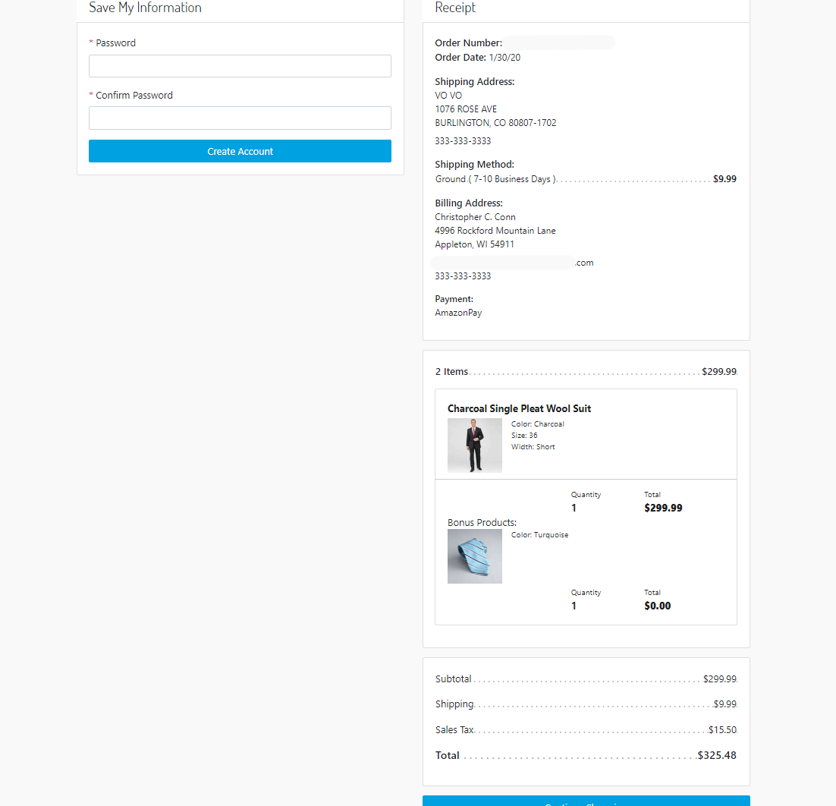

### Declined Capture in SFRA Checkout

Entries

|  |  |
| --- | --- |
| **Customer Type:** | Registered/Unregistered |
| Site Preference **Payment Intent:** | Authorized with Capture |
| Amazon responses with **Authorization Result:** | Declined |

* 1. Customer adds product to Cart.
  2. *Alternative flows:*
     1. Customer hovers the Cart icon showing up the Mini Cart page, then click the Checkout Button.
     2. Customer hovers the Cart icon showing up the Mini Cart page, then clicks on the Cart link and is redirected to the Cart page.
  3. User clicks *Amazon Pay* button then it’s redirected to the Amazon Pay hosted page.
  4. After selecting shipping address and payment method, customer clicks the button ***Continue to checkout*** and is brought back to the Checkout - Summary page.



* 1. Customer is redirected back to the SFCC checkout page and reviews the shipping address with the fields as read only. Then he clicks the button *Next: Payment*.



* 1. After clicking button ***Next: Payment****,* customer is on the Payment step and he can edit or add new billing address.



* 1. After customer clicked the button ***Next: Place Order*** will be in the review page.



* 1. Customer clicks button **Place Order**.
  2. Customer is redirected to the Processing payment Amazon Pay hosted page.
  3. The Charge is **Declined**, and the ***buyer can not be charged***.
  4. An order is created and failed not being related/connected to any customer account and its status will be **Failed**.
  5. Customer is redirected to the Cart page that will show a message for the failed payment attempt.  
     

## Limitations, Constraints

The Amazon Pay Salesforce Commerce Cloud cartridge has the following limitations:

- The Amazon Pay cartridge is compatible with Salesforce Commerce Cloud Storefront Reference Architecture 4.3.0.

- The Amazon Pay cartridge is limited to merchants in US, UK, JP and Germany markets. The cartridge is configured via Business Manager for the corresponding country.

- Shipping to multiple addresses is out of scope for this implementation of the cartridge.

- This implementation assumes no integration with a third-party order management system.

## Compatibility

The Amazon Pay cartridge is available since version Salesforce Commerce Cloud 20.2 and it was built using the version 4.3.0 of Storefront Reference Architecture. The cartridge might require updates for future versions of SFRA.

In order to install and use properly do the following.

- Download and install Node.js (<https://nodejs.org/en/download/>).

- Download the cartridge***.***

- Update the paths of base to the name of your base cartridge on the package.json inside the int_amazonpay_sfra.

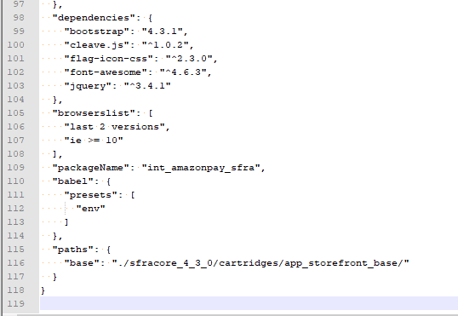

- Inside the root folder of the cartridge run npm install.

- After the completion of installing packages you can compile scripts and styles:

* 1. .js files with npm run compile:js
  2. .scss files with npm run compile:scss

- Once you have the compiled files and uploaded them to the current code version you are enabled to start to work.

## Privacy, Payment

Salesforce Commerce Cloud system collects shipping and billing address information from Amazon Pay.

Salesforce Commerce Cloud system does not collect information regarding credit cart and does not process credit card payments. All credit card processing is done on Amazon Pay system.

# Implementation Guide

## Amazon Pay Cartridge Components

Cartridge Name

* + int_amazonpay_sfra

Controllers

* + AmazonPay.js
  + APN.js
  + Cart.js
  + Checkout.js
  + CheckoutShippingService.js
  + IPN.js
  + Order.js

Client-Side Files

* + client/default/js/amazonPay/amazonPay.js
  + client/default/js/checkout/billing.js
  + client/default/js/checkout/checkout.js
  + client/default/js/amazonPay.js
  + client/default/js/checkout.js
  + client/default/js/util.js
  + client/default/scss/checkout/_checkouComponents.scss
  + client/default/scss/checkout/checkout.scss
  + client/default/scss/checkout/checkoutLogin.scss
  + client/default/scss/components/_creditCardField.scss
  + client/default/scss/components/_formField.scss
  + client/default/scss/components/_bootstrap-custom-import.scss
  + client/default/scss/components/_bootstrapOverrides.scss
  + client/default/scss/components/_variables.scss

Scripts

* + models/order.js
  + hooks/payment/processor/amazon_pay_form_processor.js
  + hooks/payment/processor/amazon_pay.js
  + lib/AmazonPayRequest.js
  + lib/pssSig.js
  + middleware/apn.js
  + services/charge/amazonChargeService.js
  + services/charge/amazonChargeServiceCallback.js
  + services/chargePermission/amazonChargePermissionService.js
  + services/chargePermission/amazonChargePermissionServiceCallback.js
  + services/checkoutSession/amazonCheckoutSessionService.js
  + services/checkoutSession/amazonCheckoutSessionServiceCallback.js
  + services/refund/amazonRefundService.js
  + services/refund/amazonRefundServiceCallback.js
  + services/amazonServicesConstants.js
  + util/amazonPayUtils.js

Templates

* + default/apn/authorizationEmail.isml
  + default/apn/chanreEmail.isml
  + defaults/apn/refundEmail.isml
  + default/cart/cart.isml
  + default/cart/checkoutButtons.isml
  + default/checkout/billing/paymentOptions/amazonPayContent.isml
  + default/checkout/billing/paymentOptions/amazonPayTab.isml
  + default/checkout/billing/paymentOptions/creditCardContent.isml
  + default/checkout/billing/paymentOptions/paymentOptionsContent.isml
  + default/checkout/billing/paymentOptions/paymentOptionsSummary.isml
  + default/checkout/billing/paymentOptions/paymentOptionsTab.isml
  + default/checkout/billing/billing.isml
  + default/checkout/shipping/shipmentCard.isml
  + default/checkout/shipping/shippingAddress.isml
  + default/checkout/shipping/shippingMethodOneClick.isml
  + default/checkout/shipping/shipping.isml
  + default/checkout/checkout.isml
  + default/checkout/checkoutLogin.isml
  + default/common/layout/checkout.isml
  + default/common/layout/page.isml
  + default/resources/appresources.isml
  + en_US/cart/cart.isml
  + en_US/checkout/checkout.isml
  + en_US/checkout/checkoutLogin.isml
  + jp_JP/cart/cart.isml
  + jp_JP /checkout/checkout.isml
  + jp_JP /checkout/checkoutLogin.isml
  + resources/amazon.properties

## Setup

*Amazon Pay cartridge is delivered with additional data in a ZIP archive containing the following folders and files:*

***- documentation*** *– LINK integration document;*

*-* ***int_amazonpay_sfra*** *– Amazon Pay cartridge;*

***- metadata*** *– metadata.zip file for metadata changes.*

*The setup process is described below.*

*Install the following cartridges:*

* 1. *int_amazonpay_sfra – Amazon Pay cartridge -> contains most of AMZ Pay functionality;*
  2. *app_storefront_base;*
  3. *bm_app_storefront_base;*
  4. *modules*

*In order to install a cartridge into the Salesforce Commerce Cloud UX Studio IDE, the steps below should be followed:*

*1. Open Salesforce Commerce Cloud UX Studio;*

*2. Click File -> Import -> General -> Existing Project into Workspace;*

*3. Browse to the* ***cartridge*** *directory;*

*4. Click* ***Finish****.*

*5. Click* ***OK*** *to link the cartridge to the sandbox.*

## Configuration

### Assign the Cartridge to the Site

1. Log in to Business Manager.
2. Click Administration -> Sites -> Manage Sites.
3. Select the site for which you want to enable the Amazon Pay integration.
4. Select the Settings tab.
5. In the cartridges field add int_amazonpay_sfra to the existing list of cartridges int_amazonpay_sfra:app_storefront_base:modules

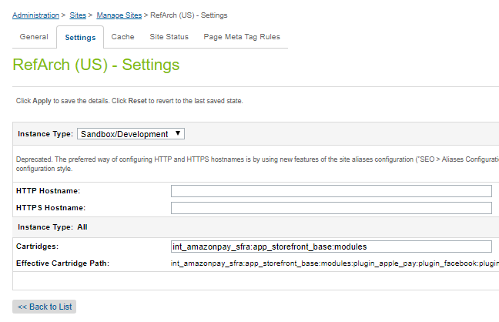

### Import Metadata

1. Browse to the Amazon Cartridge folder.
2. Navigate to the metadata folder.
3. Create a ZIP archive of the metadata folder. The name of the archive should be the same as the metadata folder name.
4. Log into the Business Manager;
5. Go to Administration -> Site Development -> Import & Export;
6. Under Import & Export Files, click Upload;
7. Click Browse;
8. Locate and select metdata.zip file;
9. Click Upload;
10. Click <<Back (below the import file list) to return to the Import & Export page;
11. Under Meta Data, click Import;
12. Select the metadata.zip file;
13. Click Next>> and wait for Business Manager to validate the import file;
14. Click Import>> to start the import process;
15. When Success appears in the Status column the site-preference object definitions were successfully imported.

### Configure Amazon Pay Site Preferences

#### **Enable Amazon Pay**

Allows enabling/disabling the Amazon Pay cartridge. By default, Amazon Pay is disabled so is required to change the selected value to **Yes** to enable it.



#### **Environment**

Allows to set the storefront to work as sandbox or production environment. By default, this preference is set to ***Sandbox***. You need to set the value to ***Live*** for Production environments. It is recommended to test the plugin in sandbox mode first before going live.



#### **Region**

Allows specifying - **US**, **EU/UK** or **JP**. The default Region is US. To use another region select another value. With this preference we configure the endpoints to be used through the Amazon Pay API.

Possible values are:

* **US (com)**
* **UK/EU (eu)**
* **JP (jp)**



#### Checkout Type

Use a type of checkout with more or less steps. This preference is very important since affects the customer experience.

Either checkouts we use the data that comes from Amazon Checkout Session.

One Step consist in one single page that shows every detail for order, as per the shipping address, shipping method, billing address, payment information and the button to click place order. In this checkout, if the required information is valid, the buyer can finalize his shopping experience very quickly.

SFRA Checkout follows the out of the box checkout implemented in Storefront Reference Architecture, that is needed to go through the shipping, billing and payment options then the confirmation page to be possible to place order.

Possible values are:

**One Step Checkout**

**SFRA Checkout**



#### **Merchant ID**

The Amazon Pay identifier for the Merchant. You can find this value in Amazon Seller Central.

Under the Amazon Pay Sandbox view go to ***Integration*** *>* ***MWS Access Key*** and you will find the Merchant ID value you need to save on the SFCC side.

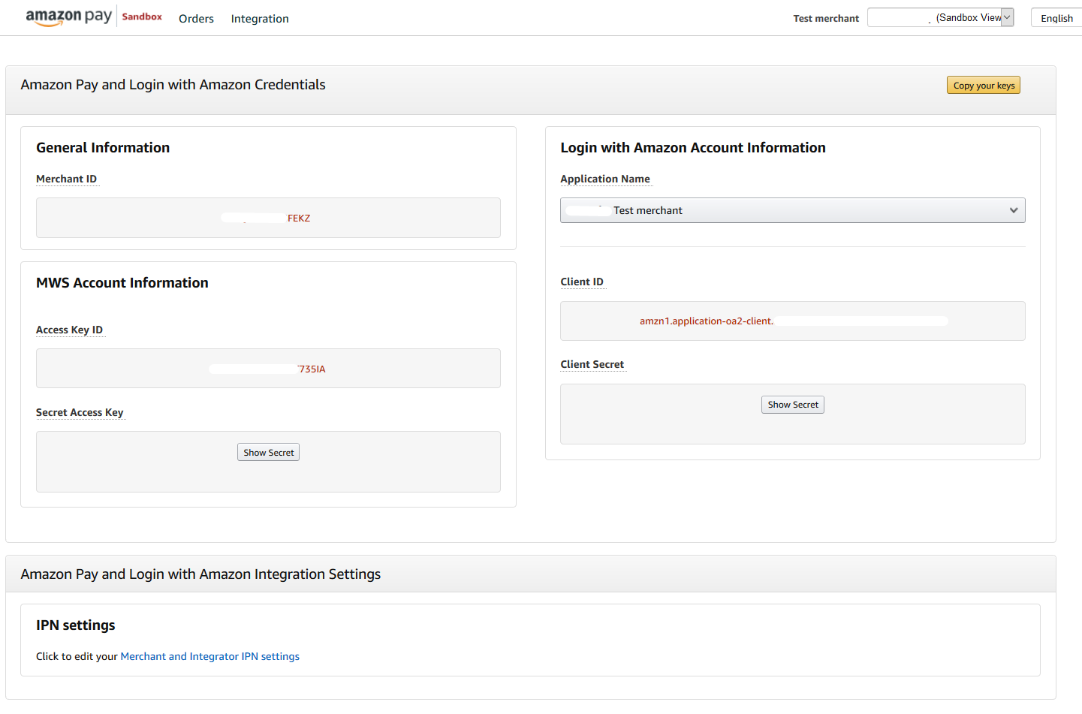



#### Merchant Store Name

The store name that will appear in emails sent by Amazon Pay to the buyers.



#### Store ID

This is the Login with Amazon client ID, which can be retrieved from "Login with Amazon" in Seller Central. It allows the configuration of name, privacy policy and logo during checkout. This is the same Client ID code assigned when registering a new application in **Login with Amazon**.



The store id can be found in two places in Amazon Seller Central. First you can go to ***Amazon Pay Sandbox View*** *>* ***Integration*** *>* ***MWS Access Key***.



Or you can go to ***Login with Amazon*** view to get the ***Client Id*** to be save in SFCC as the Store ID.

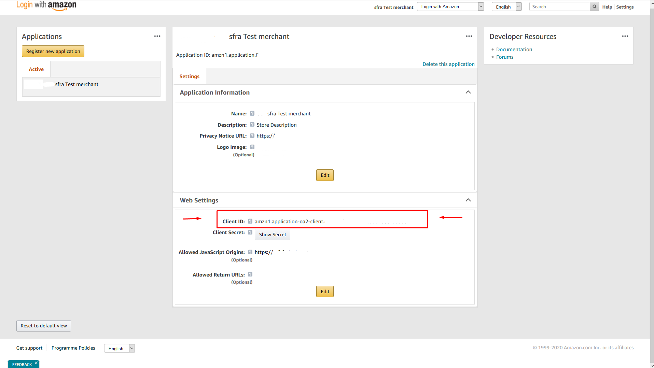

#### Note to Buyer

Description of the order that will appear in emails sent by Amazon Pay to the buyers.



#### Capture Soft Descriptor

Description shown on the buyer's payment instrument statement on capturing funds. Max length: 16 characters.

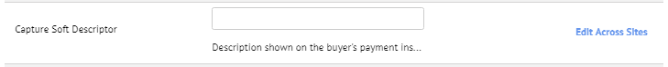

#### Refund Soft Descriptor

Description shown on the buyer's payment instrument statement on refunding funds. Max length: 16 characters.



#### Product Type

Type of Amazon Pay integration.



#### Payment Intent

Specifies the payment flow for charging the buyer. Possible values are:

* Confirm
* Authorize
* Authorized with Capture



#### Public Key ID

Provided by Amazon Pay account manager. Please refer to the ‘Get you PublicKeyId’ section https://amazonpaycheckoutintegrationguide.s3.amazonaws.com/amazon-pay-checkout/get-set-up-for-integration.html#4-get-your-publickeyid.



#### Private Key

Secret key generated by the merchant. The key format supported is PKCS#1 / PKCS#5

Note: The automatically generated keys from Amazon Seller Central have the PKCS#8 format, which is **NOT COMPATIBLE**. Please consider creating locally an RSA key (PKCS#1 / PKCS#5) and add it by following the described steps:

http://amazonpaycheckoutintegrationguide.s3.amazonaws.com/amazon-pay-api-v2/manually-generating-key-pairs.html

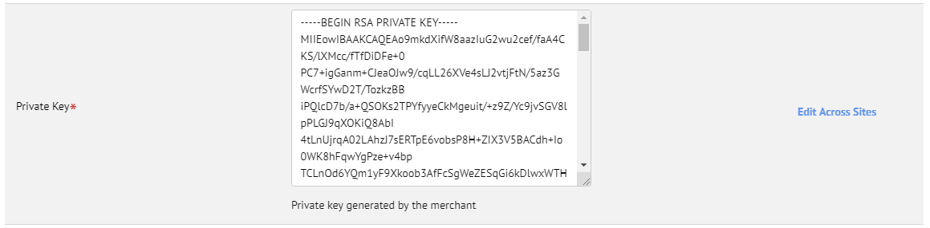

#### APN Shared Token

Shared token to be check the validity of APN requests sent to cartridge.



#### Message Digest Algorithm

The chosen algorithm in this preference is used to create a hash and the hex of the value in the APN Shared Token to ensure only request with the token can be made.

Possible values are:

* **MD2**
* **MD5**
* **SHA**
* **SHA-1**
* **SHA-256**
* **SHA-512**



#### Simulation Code

Use this to simulate different behaviors.

You should use like this: Action:Code. I.e.: Charge:HardDeclined.

Use the values contained in the Amazon Pay documentation [Sandbox Simulations](https://amazonpaycheckoutintegrationguide.s3.amazonaws.com/amazon-pay-checkout/sandbox-simulations.html).

Action represents the Amazon Pay object, so they need to be without spacing, like this:

* CheckoutSession
* Charge
* ChargePermission
* Refund



#### Locales Map

Adds locales map to be used as configuration for checkout language for the given regions. This configuration is used in combination with Region. If a merchant located in US uses the locale without country code, like ***en*** the checkout language added in the [Amazon Pay button](https://amazonpaycheckoutintegrationguide.s3.amazonaws.com/amazon-pay-checkout/add-the-amazon-pay-button.html#3-render-the-button) will be ***en_US***.

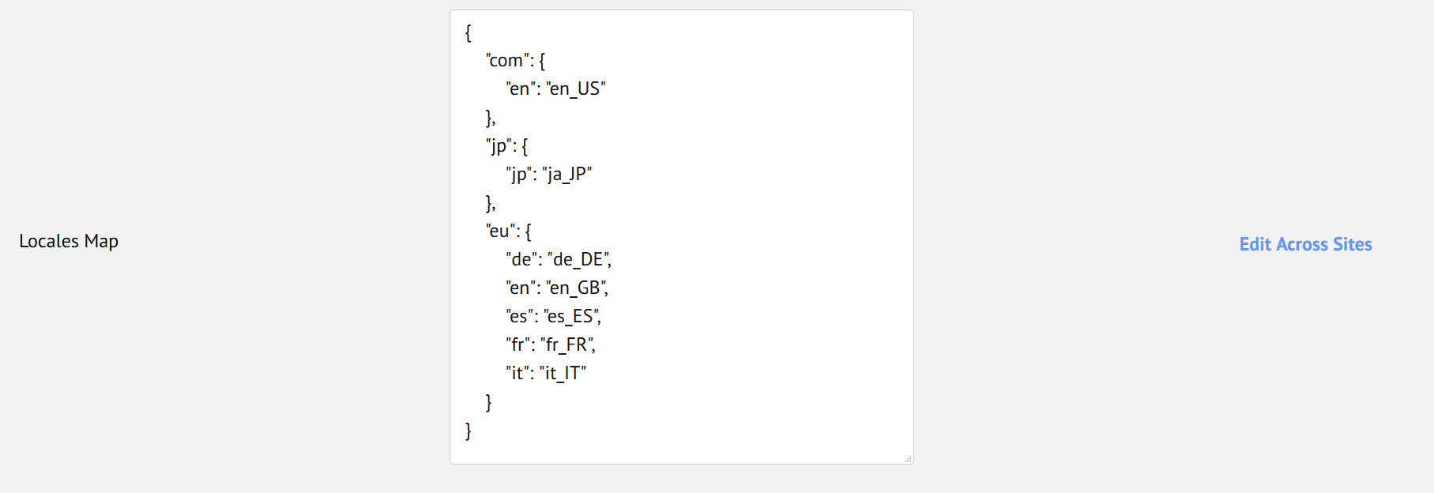

## Custom Code

This section describes the integration of the cartridge with site based on SFRA structure and provides a list of all affected controllers/scripts and templates and explanation for the changes were done.

### Controllers

#### Cart.js

Extends the controller functionality to add an error message to the view data.

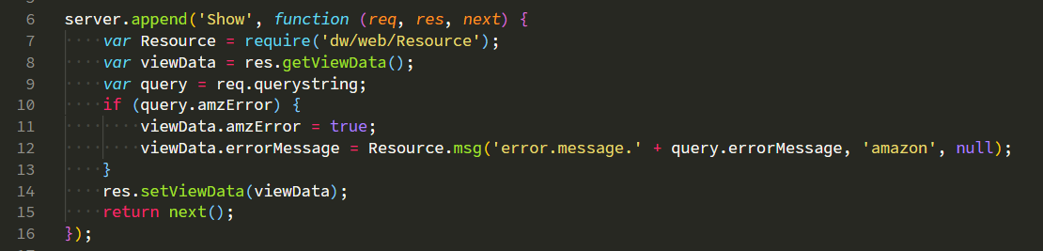

#### Checkout.js

Extends the original controller and prepends the request to check if Amazon Pay Redirect URL is not empty, to make it empty to avoid misconfiguration out of the box checkout for SFRA. In the same time remove the Amazon Pay Payment Instruments to the case other Payment Instrument is in use, like a Credit Card to avoid misunderstandings of which Payment Instrument was really used in the Order.

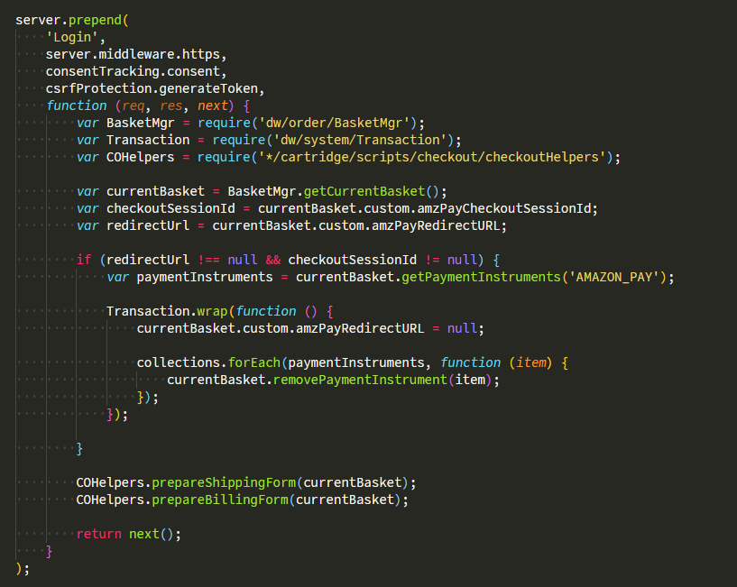

Use the same logic from Checkout-Begin and prepend adding to it pieces of code to ensure the shipping address selected in Amazon Pay Checkout Session could not be changed in SFCC side.

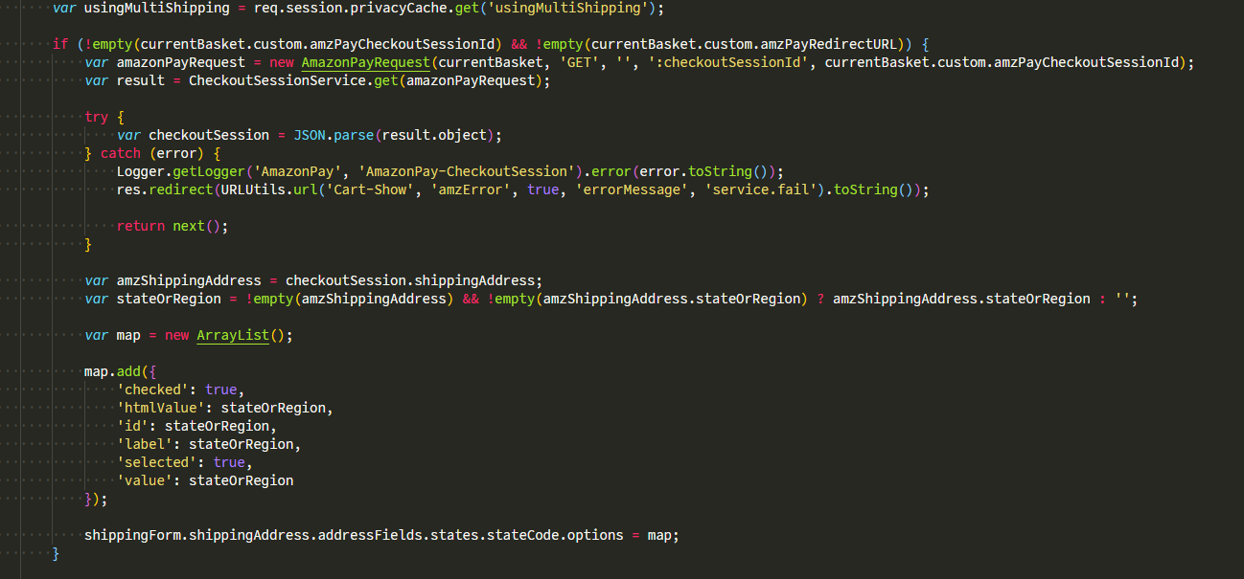

#### CheckoutShippingServices.js

Extends the original controller to add an prepend to the request of selection of shipping method to use the shipping address present in the Amazon Pay Checkout Session and update it with the new total amount. So, every time the buyer selects the shipping method it updates payment detail amount of the Amazon Checkout Session. With that we have always the total gross amount of basket being reflected on the Amazon Pay.

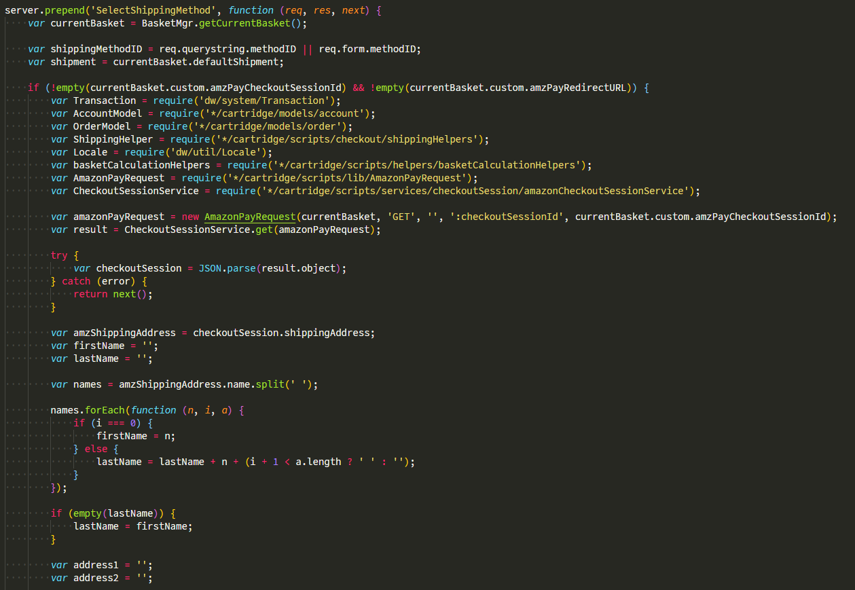

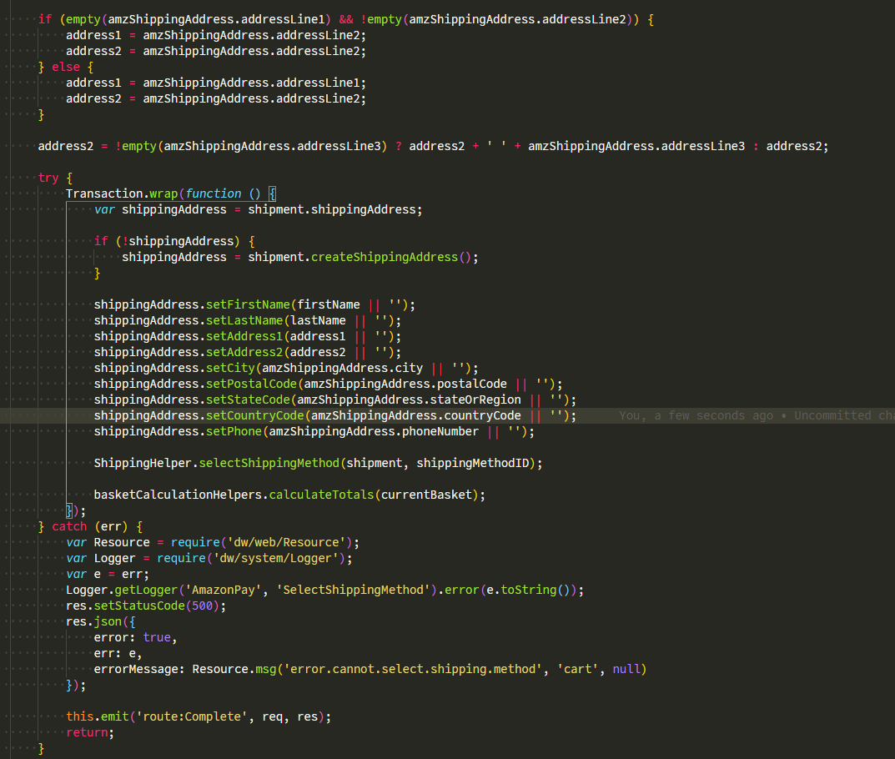

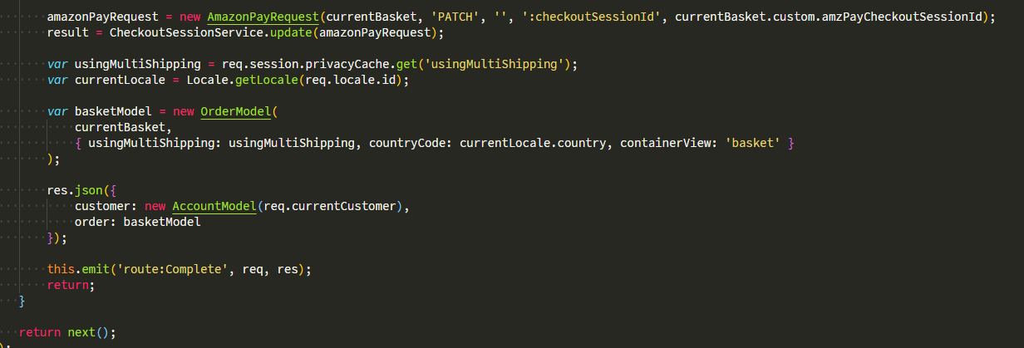

#### Order.js

Extends the original controller and removes the condition for current customer id not being the same as the order.

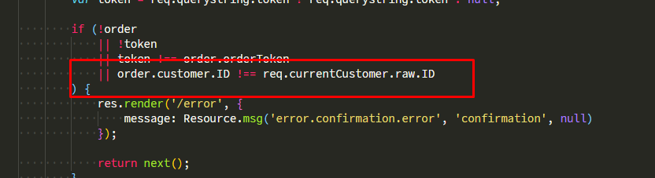

### Scripts

1. billing.js

Adds the ability to put information into the payment and confirmation pages.

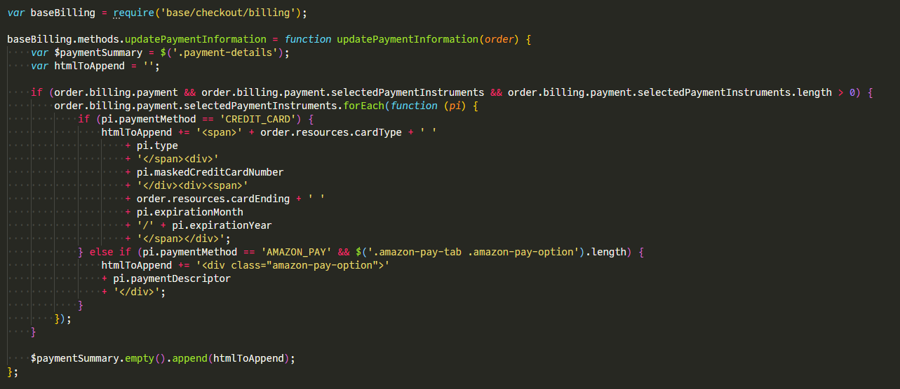



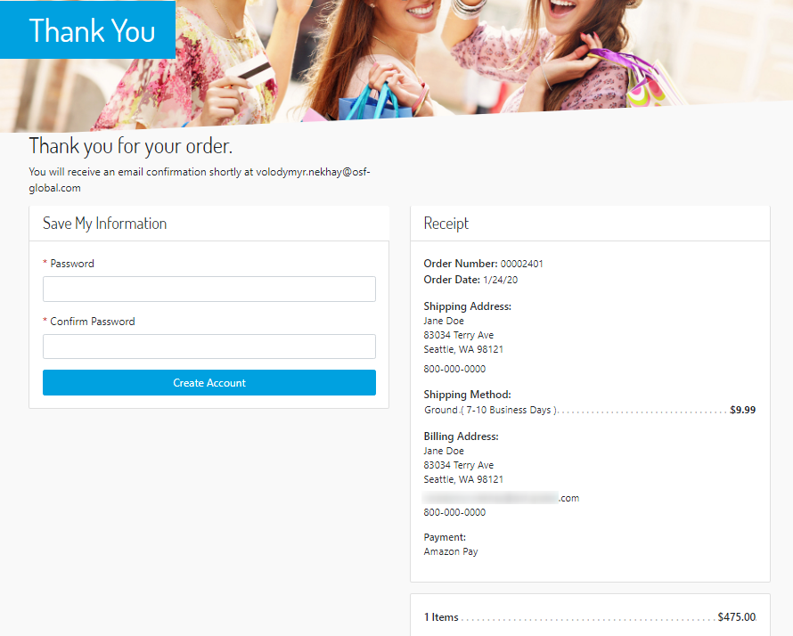

1. checkout.js

Adds a condition and checks if the payment in the checkout is Amazon Pay. If yes, when the customer clicks “Place Order”, it calls the AmazonPay-Prepare endpoint to prepare and to create the order preemptively. If the ajax call returns successful, replace the location to the Amazon Pay Redirect URL present in Checkout Session so to complete the Checkout.

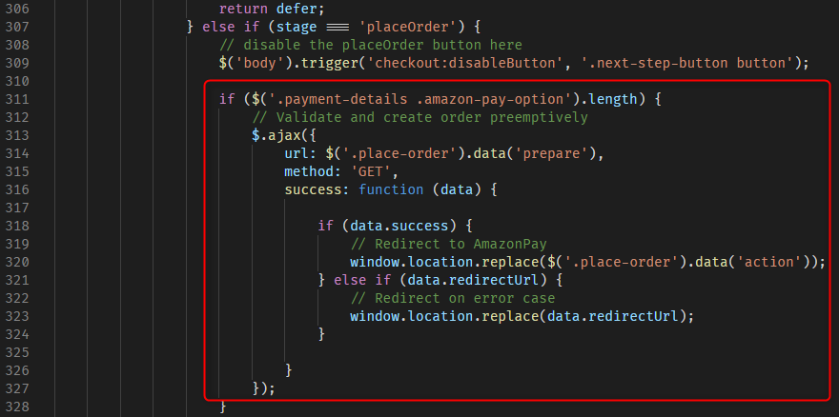

### Template Modifications

To integrate the Amazon Pay cartridge, the following storefront cartridge templates were updated:

#### default/cart/cart.isml

Set a variable ***sitePreferences***and add the Amazon Pay script and the client side script for the cartridge if the Amazon Pay integration is enabled.

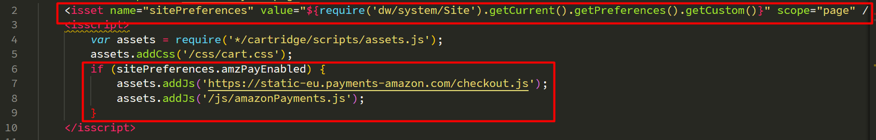

#### default/cart/checkoutButtons.isml

Sets a variable ***sitePreferences*** and adds a div with id **AmazonPayButtonCart** if the Amazon Pay integration is enabled.

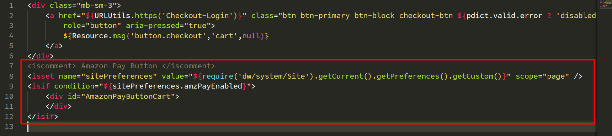

#### default/checkout/billing/paymentOptions/amazonPayContent.isml

Creates a template with given id and classes to be able to follow the same pattern as the SFRA design to show the payment option that is being used in the checkout flow.



#### default/checkout/billing/paymentOptions/amazonPayTab.isml

Creates the template that will bind the template referenced in the element a inside the attribute **href**.

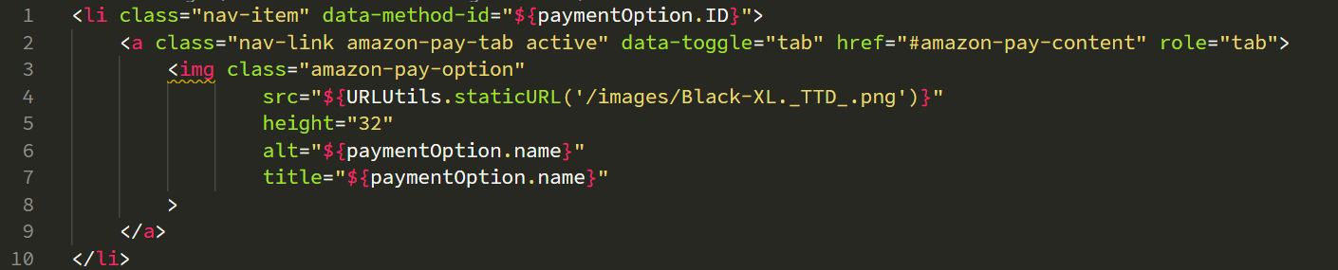

#### default/checkout/billing/paymentOptions/creditCardContent.isml

Adds the class *active* if there is no Amazon Pay Redirect URL in the basket.

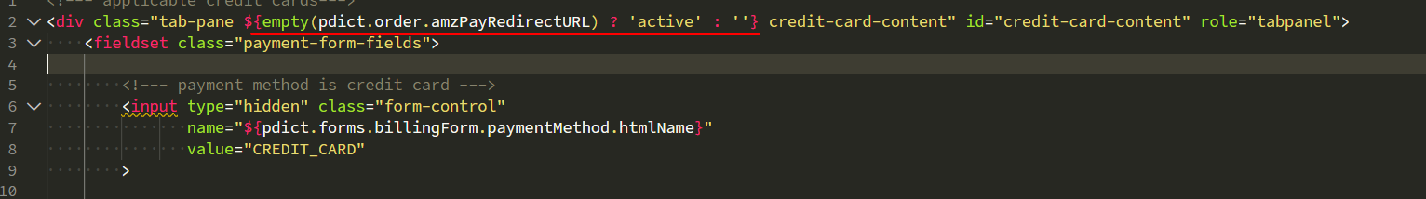

#### default/checkout/billing/paymentOptions/paymentOptionsContent.isml

Adds the include to amazonPayContent if the payment instrument ID is AMAZON_PAY.

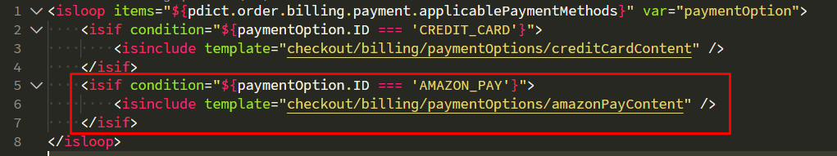

#### default/checkout/billing/paymentOptions/paymentOptionsSummary.isml

Adds the div to show the payment descriptor with information of payment used by the buyer.

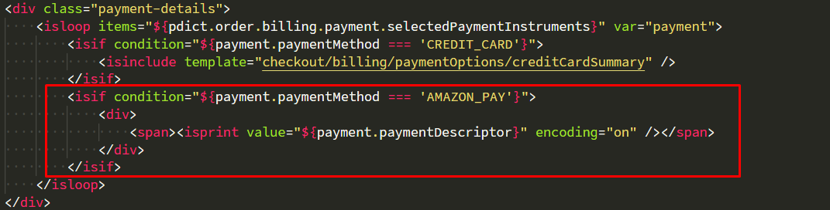

#### default/checkout/billing/paymentOptions/paymentOptionsTab.isml

Adds a condition inside the loop to check if there is Amazon Pay Redirect URL inside the container to show the Amazon Pay tab template.

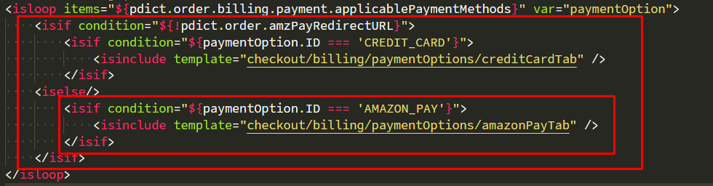

#### default/checkout/billing/billing.isml

Adds condition for setting the action and address mode to be used in the billing form.

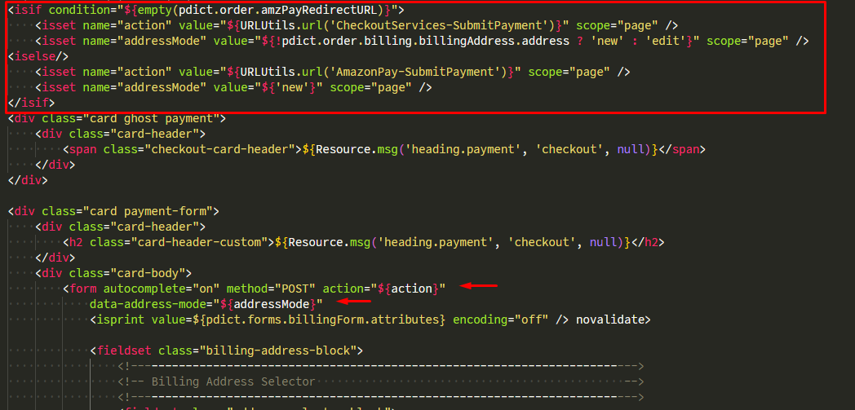

#### default/checkout/shipping/shipmentCard.isml

Adds condition to set the address mode.

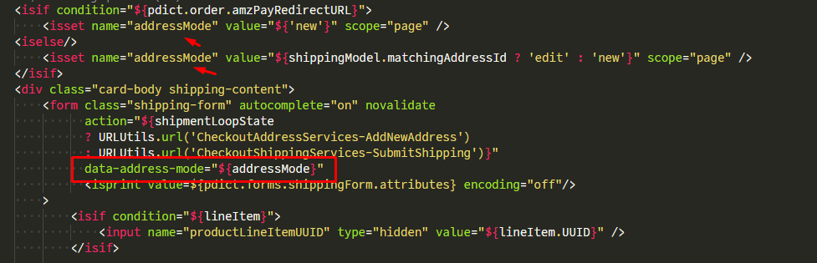

#### default/checkout/shipping/shippingAddress.isml

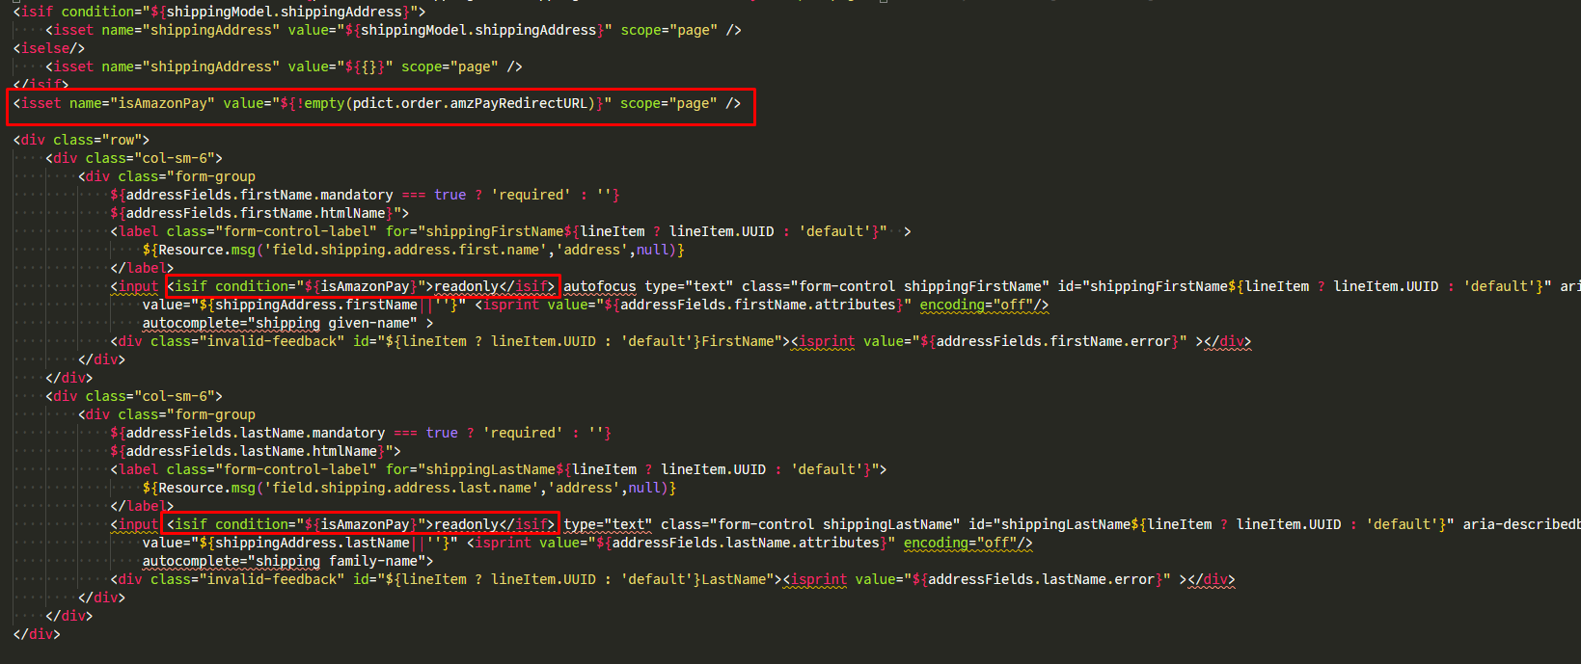

#### default/checkout/shipping/shippingMethodOneStep.isml

Creates a template to be used in the One Click Checkout. This template enables selection of shipping method, since user would not be enabled to select it on this checkout flow, as he could in SFRA Checkout.

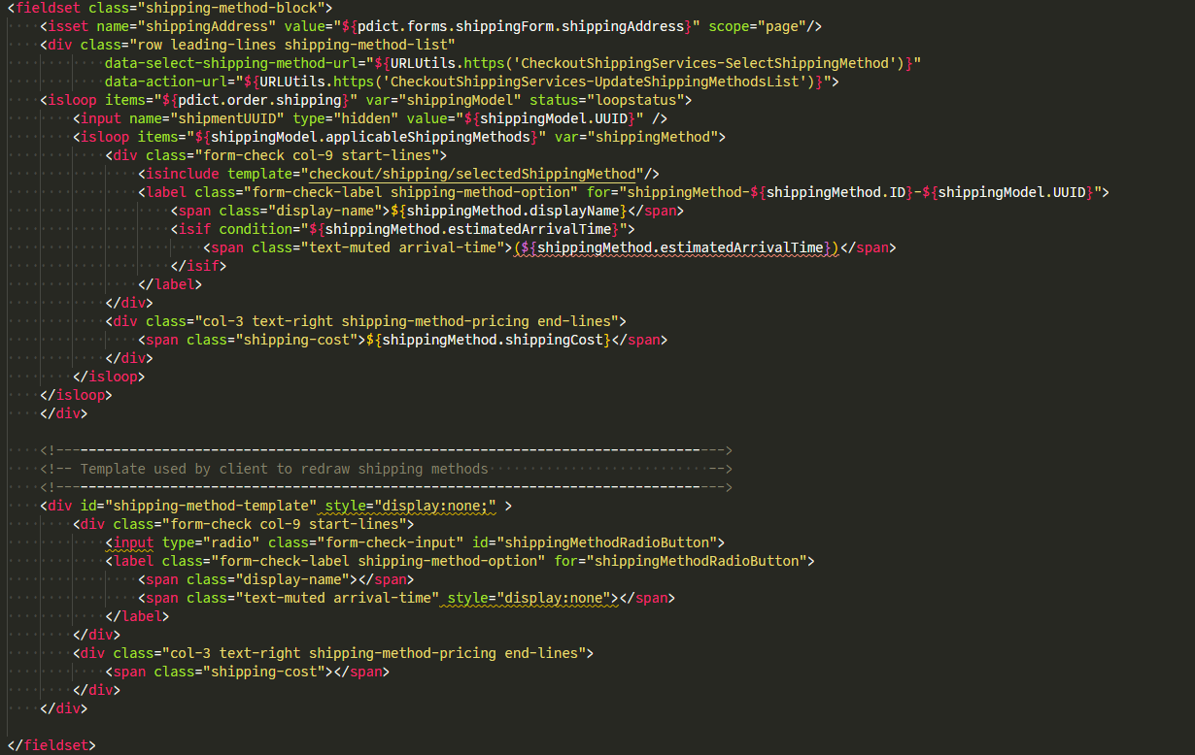

#### default/checkout/checkout.isml

Sets a variable with the Site Preferences and adds a condition to check if the Amazon Pay integration is enabled, if so adds the scripts required to the functioning of cartridge and adds the div to be used by Amazon Pay script to add the Amazon Pay button.

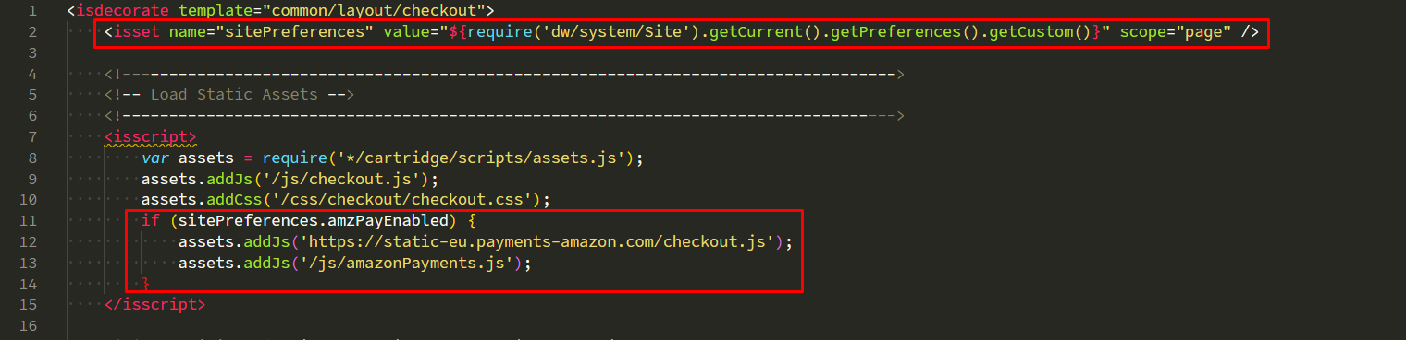

#### default/checkout/checkoutLogin.isml

Sets a variable with the Site Preferences and adds a condition to check if the Amazon Pay integration is enabled, if so adds the scripts required to the functioning of cartridge and adds the div to be used by Amazon Pay script to add the Amazon Pay button.

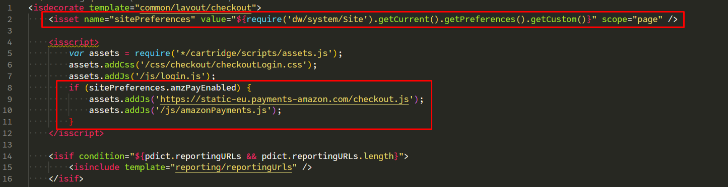

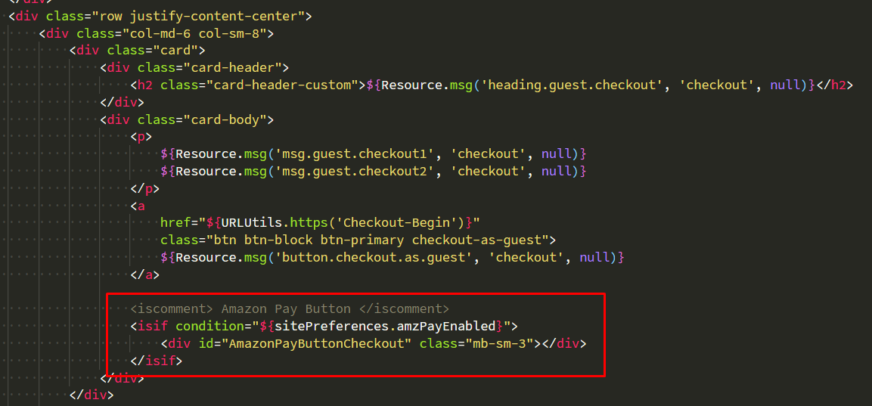

#### default/common/layout/checkout.isml

Adds the appresources template on this template to enable resources related to the Amazon Pay integration preferences.

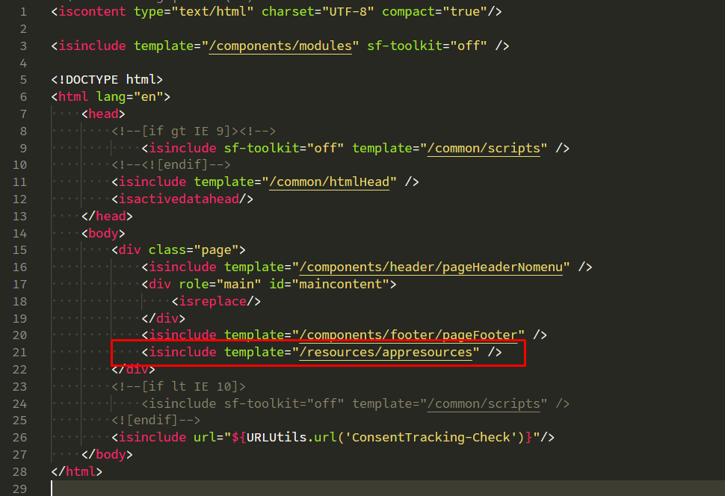

#### default/common/layout/page.isml

Adds the appresources template on this template to enable resources related to the Amazon Pay integration preferences.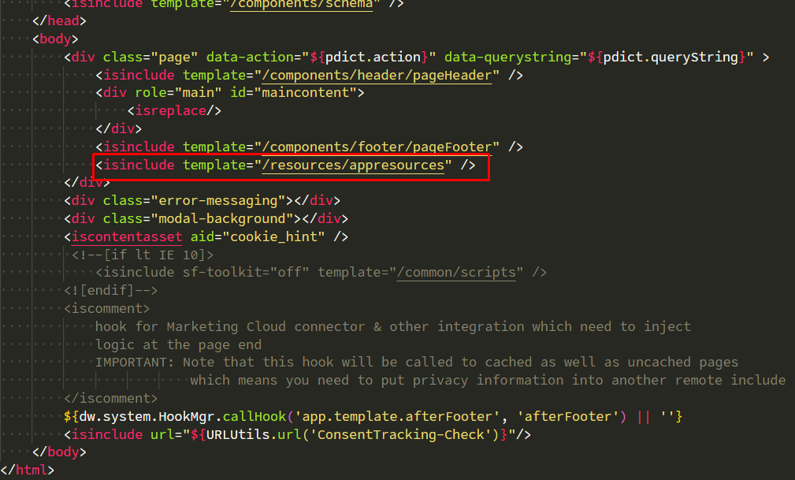

#### default/resources/appresources.isml

Adds to the window object some site preferences and URLs to be used in the checkout.

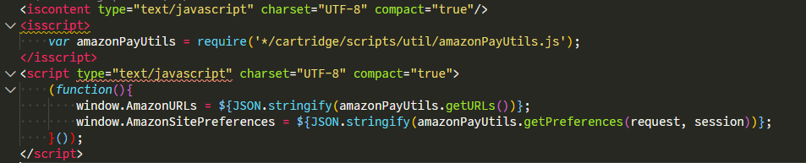

## Testing

### APN

The cartridge can be setup to work in Sandbox mode via the Business Manager Configuration screen. When in sandbox mode, real payments will not be processed.

Testing accounts for Amazon Pay can be created. Contact Amazon Pay for an account on Amazon Seller central. After you have received your account credentials, you can create testing accounts. Please see more [here](http://amazonpaycheckoutintegrationguide.s3.amazonaws.com/amazon-pay-checkout/amazon-pay-sandbox-accounts.html).

Note. Real Amazon accounts cannot be used on Sandbox mode and the other way around. Apart from the account being used, there is no difference in the API behavior between Sandbox and Production mode. The tests made and API information received in Sandbox will reflect the Production behavior.

APN Schema

|  |  |
| --- | --- |
| **{  “ChargePermissionId”: “S01-2802363-4736876”,  “ActionType”: “Authorize”,  “AuthorizeAmount”: {  “Amount”: “459.89”,  “CurrencyCode”: “USD”  } }** | |
| **ActionType** | **Possible values are: AUTHORIZE | CHARGE | REFUND Note: the values are case-sensitive so you should send the request as is.** |
| **AuthorizeAmount** |  |

1. Set Payment Intent to Confirm.
2. Place an order.
3. Run a platform to test the API like Postman/Insomnia and create a HTTP request with the schema above containing the following parts:
   1. URL: https://sandboxhost/on/demandware.store/Sites-RefArch-Site/default/APN-Notification
   2. Method: POST
   3. Body: In the format of the APN Schema.
4. Generate the JSON to be used in the request like the examples:

You should get the ChargePermissionId from the Attributes tab inside Order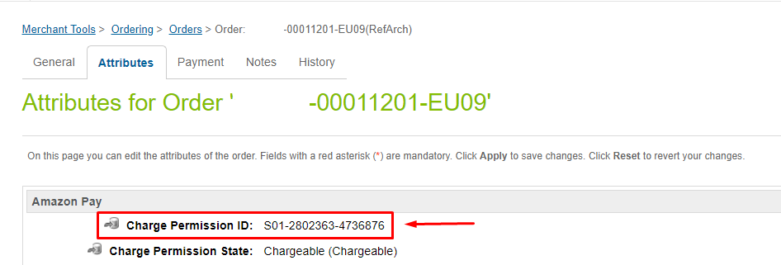

* 1. Authorize  
     **{  
      “ChargePermissionId”: “S01-2802363-4736876”,  
      “ActionType”: “Authorize”,  
      “AuthorizeAmount”: {  
      “Amount”: “459.89”,  
      “CurrencyCode”: “USD”  
      }  
     }**
  2. Capture  
     **{  
      “ChargePermissionId”: “S01-2802363-4736876”,  
      “ActionType”: “Charge”,  
      “ChargeAmount”: {  
      “Amount”: “459.89”,  
      “CurrencyCode”: “USD”  
      }  
     }**
  3. Refund  
     **{  
      “ChargePermissionId”: “S01-2802363-4736876”,  
      “ActionType”: “Refund”,  
      “RefundAmount”: {  
      “Amount”: “459.89”,  
      “CurrencyCode”: “USD”  
      }  
     }**

1. Set a value inside the preference APN Shared Token. The value you will be set is a phrase like: Salesforce Commerce Cloud; with the spaces and everything you want.



1. Then select the APN Message Digest Algorithm in the Amazon Preferences group, by default the MD5 is selected.
2. Then take the value you set on the step 5 and hash that value in some online tool, like [MD5 Hash Generator](https://passwordsgenerator.net/md5-hash-generator/) for MD5 in case you have not chosen a different algorithm on the step 5. If you choose another algorithm you can click on the tool and there you can choose to other algorithm.
3. Add the “x-apn-shared-token” to the request headers containing the hashed value you created on step 7.

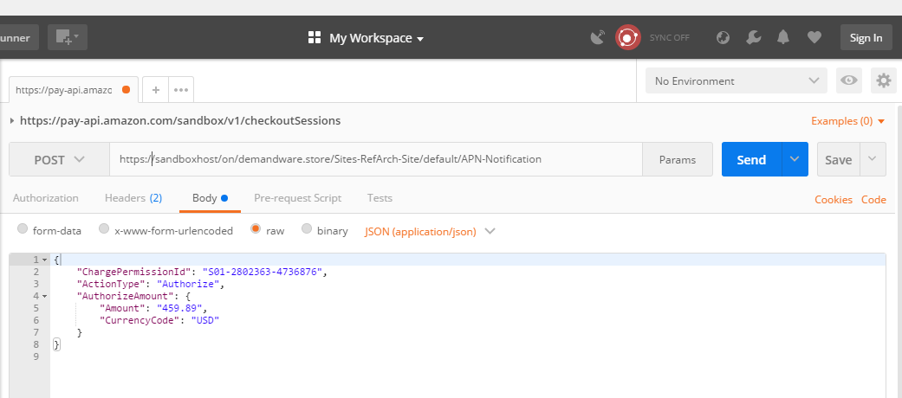

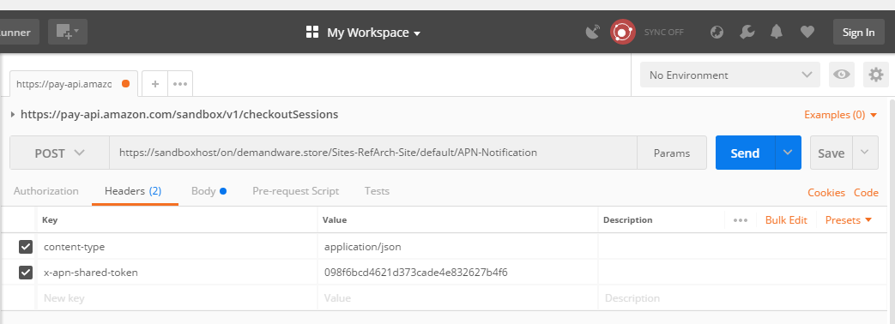

1. Run your request.

### IPN

In order to illustrate the IPN flow and the Order status both in Salesforce Commerce Cloud and Amazon’s Seller Central, the following steps should be followed:

1. Place an order.
2. Navigate in BM on the Site and go to Merchant Tools > Ordering > Orders.
3. Open the order you just placed and go to the Attributes tab.
4. You can check the attributes of the Order

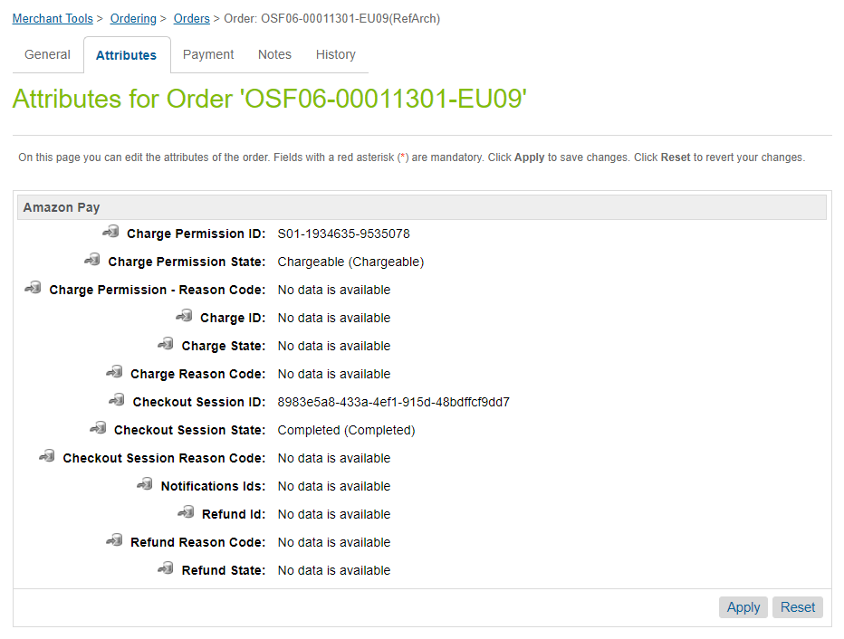

1. Go to Amazon Seller Central. Then navigate to Orders > Manage Transactions.
2. Search for the transaction with the Seller Order ID as the Order ID in SFCC.

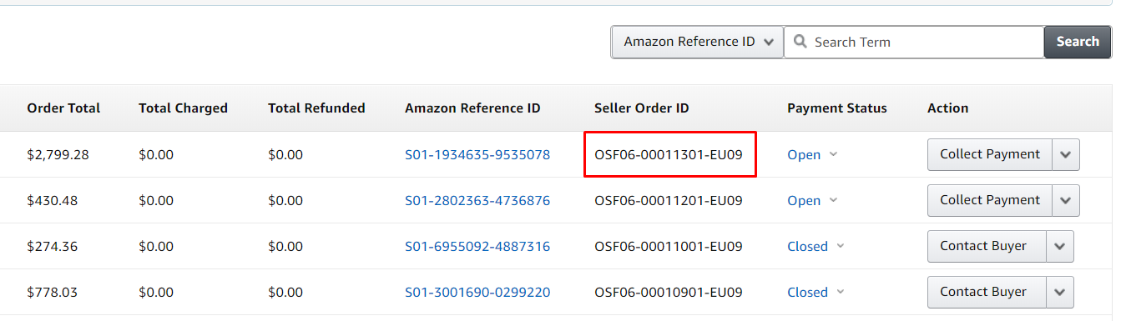

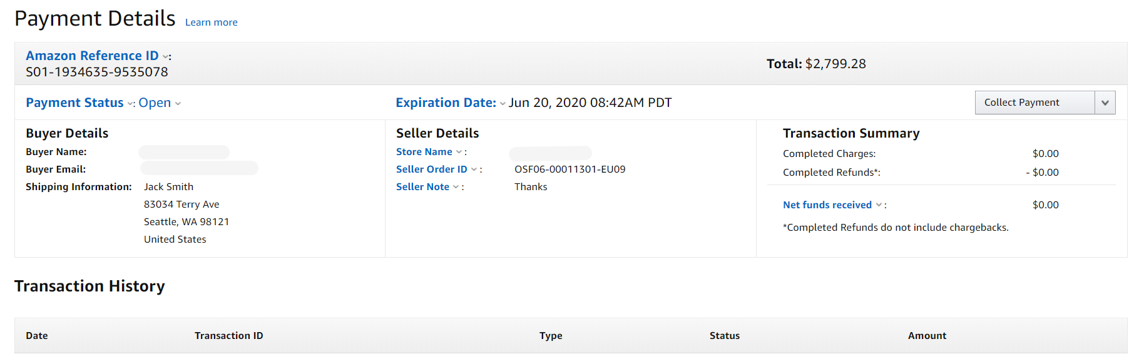

1. Click on the *Collect Payment* to Authorize and Capture the Total Amount. After clicking a pop-up will appear and there you can change the Charge Amount and put some Notes if desired to be displayed in the charge email.

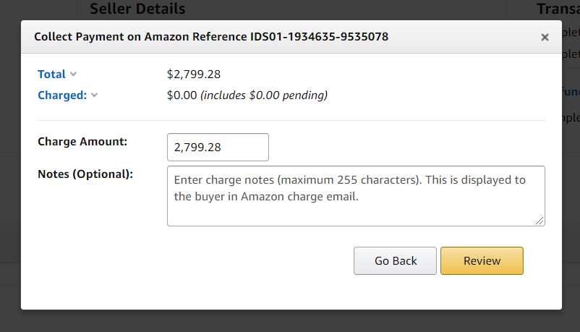

1. After Reviewing you can click the *Charge* button.

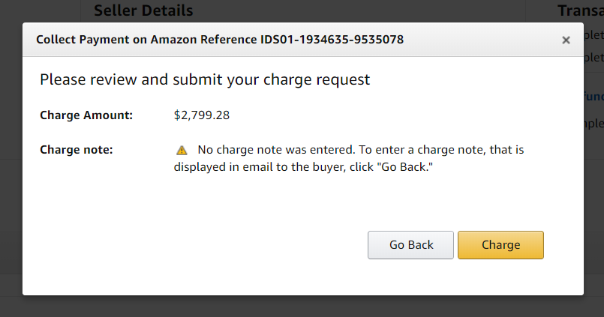

1. After you will see another screen about the receiving of Charge request.

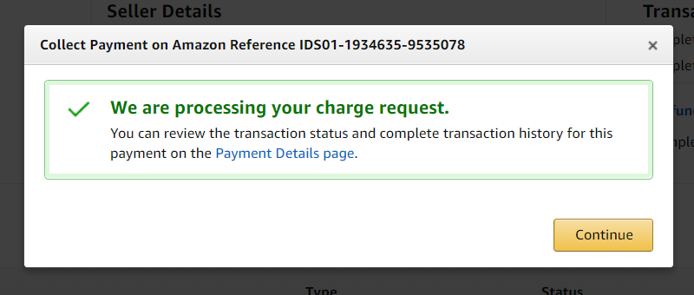

1. If the Payment Intent is Confirm, the Merchant may authorize and capture the order from Seller Central or the order may be authorized and captured from ERP system (via APN call). For each transaction, from the Transaction History tab, an Instant Payment Notification will be sent.

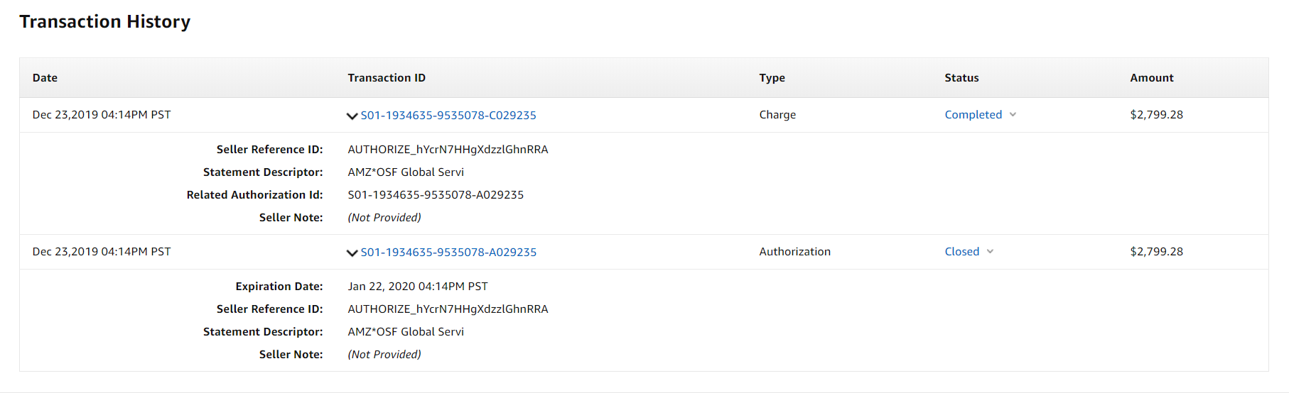

1. In SFCC Business Manager you can check the new updated attributes after some seconds.

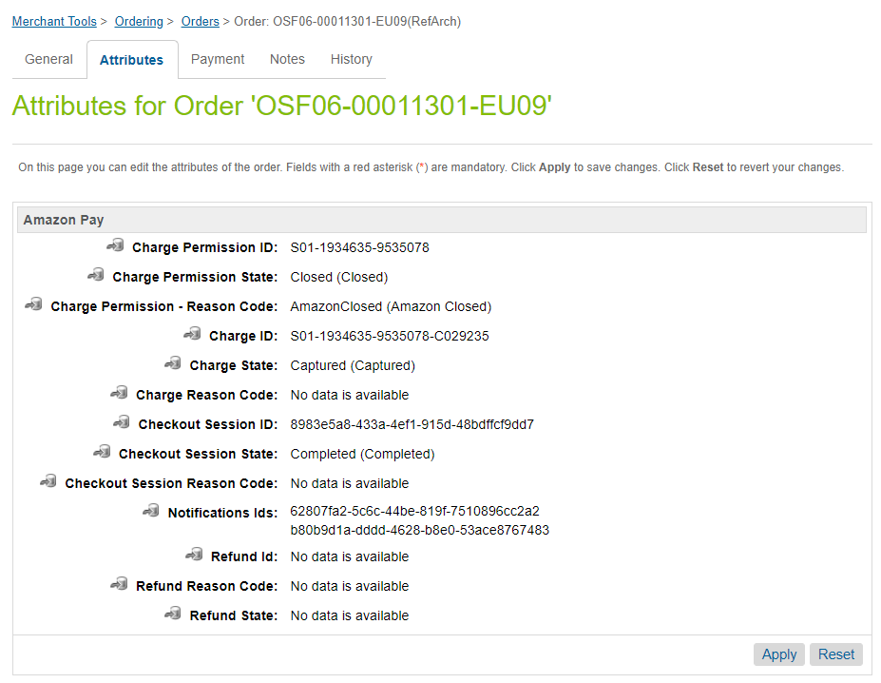

1. Navigate to the Notes tab and you will see some notes that are related to the IPN communication.

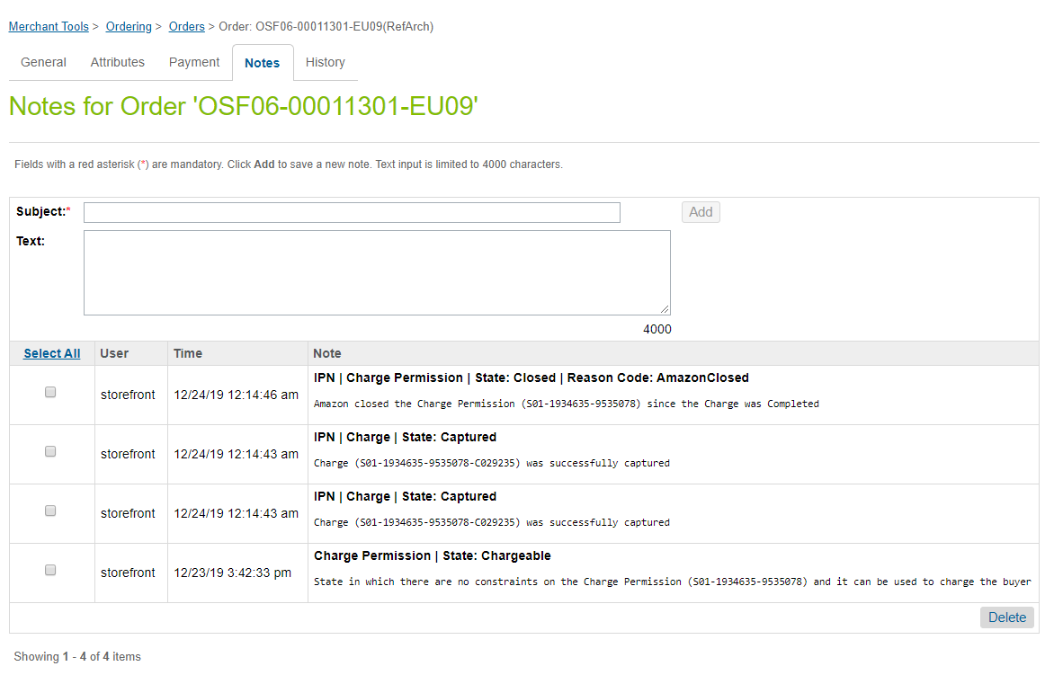

1. In Amazon Seller Central, the order Authorization appears as Closed and the Charge is Completed.

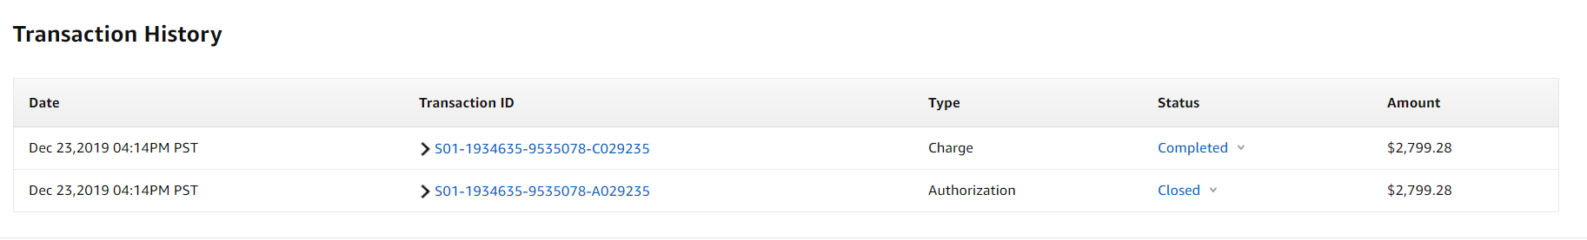

1. To create a Refund, click on the button *Refund* on the right side

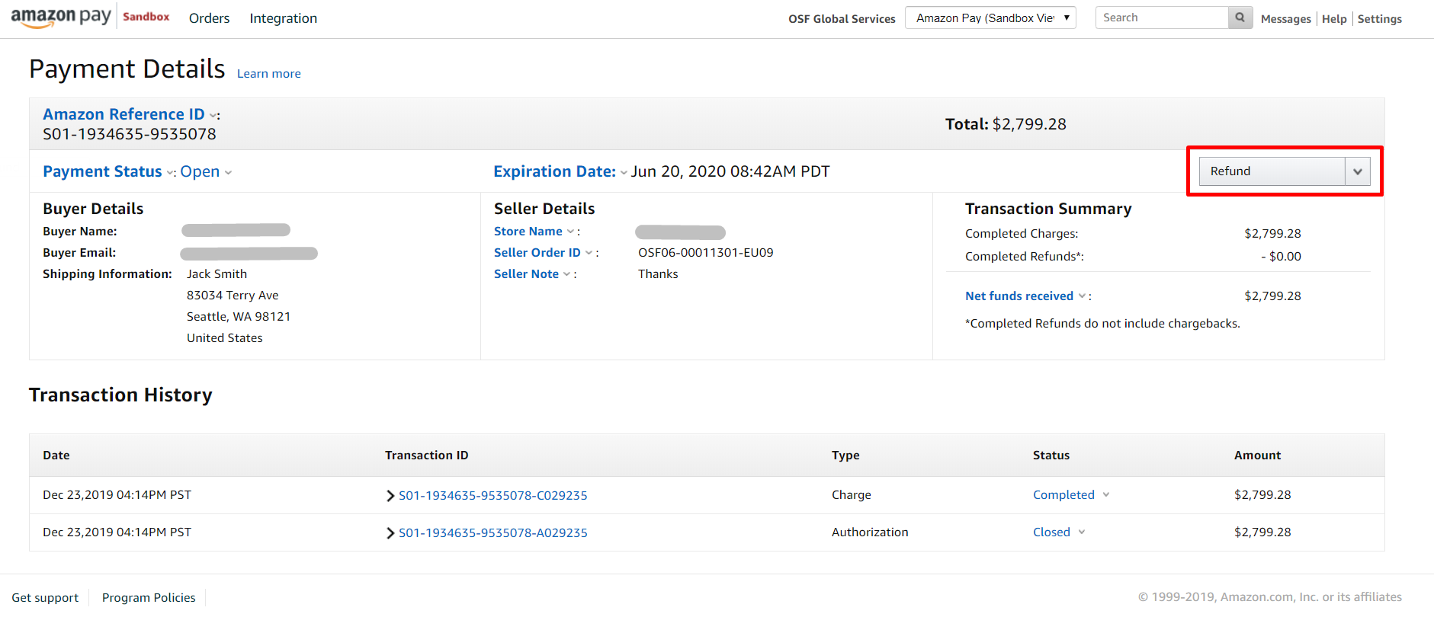

then a pop-up will appear so you can pass the Refund amount and some Notes.

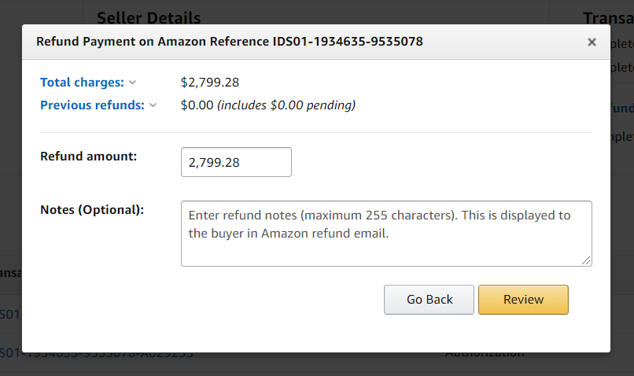

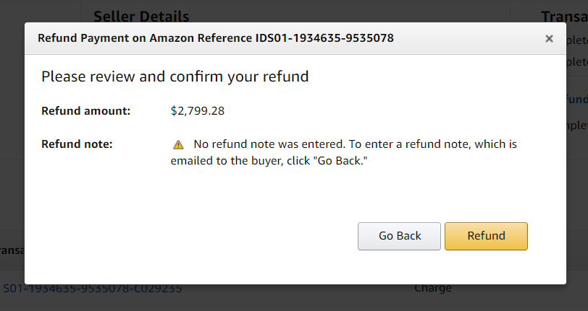

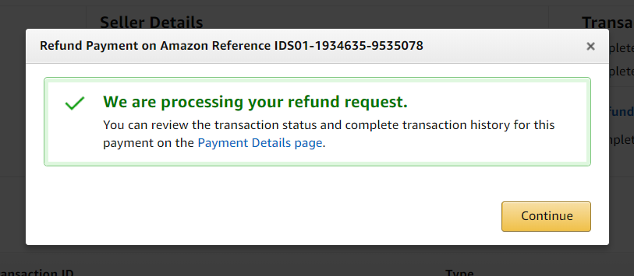

1. After the Refund is started the status will change to Pending:

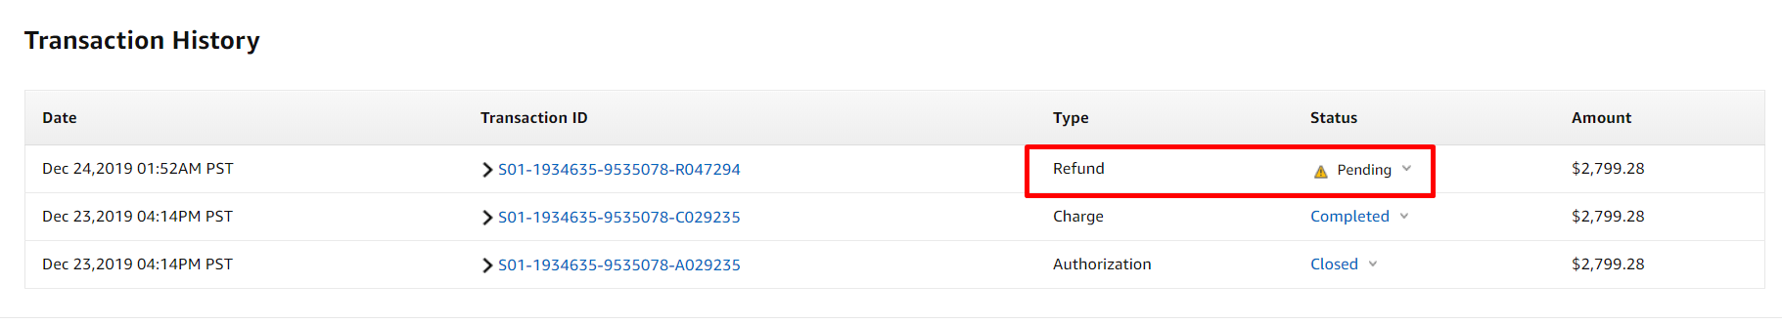

1. After some seconds the Refund will change to Completed:

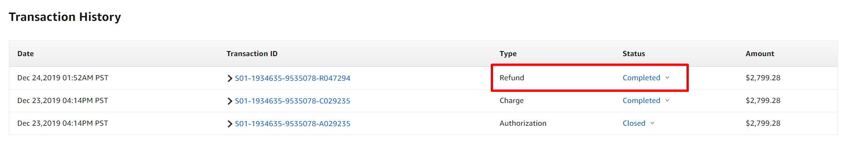

1. In SFCC Order the Attributes will updated right after the IPN message is received.

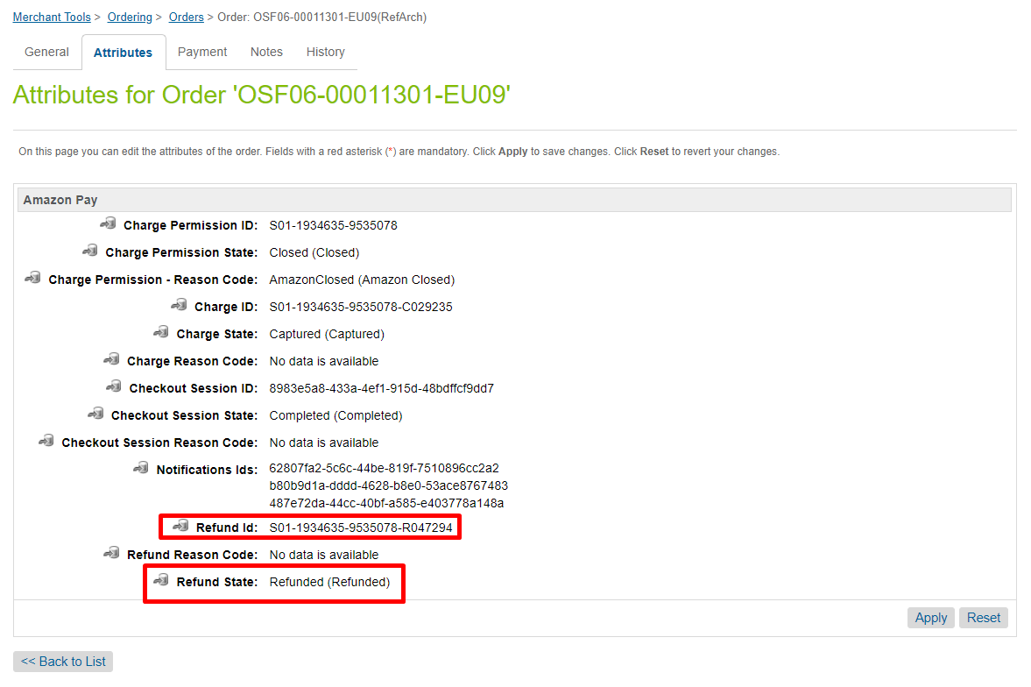

# Operations, Maintenance

## Data Storage

The cartridge stores information received from Amazon in the Order and Order Payment Instrument system objects definition via custom attributes in order to process the orders.

No credit card data stored on the SFCC side. NO custom objects in use.

## Availability

The Amazon Pay system guarantees an uptime of almost 100%. However, in case the system does not respond, customers will not be able to use Amazon Pay to checkout and will have to use a different payment method.

Customers are always able to logout from Amazon Pay checkout method, thus enabling a flexible checkout process. If you continue to see any issues where the Amazon widgets and/or buttons and experience is not rendering/working, please contact your Amazon representative so that we may investigate this further. These orders will not able to proceed with Amazon payment option and you may need to disable it until the issue is resolved.

## Support

Please contact Amazon Pay in case fixes or improvements are required.

# User Guide

## Roles, Responsibilities

Amazon Pay cartridge configuration is done through the Business Manager Site preferences one time at the time of installation and setup. Amazon Pay can be enabled or disabled through the configuration in Business Manager.

## Business Manager

There is a section Configure Amazon Pay Site Preferences under Configuration.

Please use that section to see all the BM Settings.

## Storefront Functionality

The Storefront Functionality is described in the Use Cases and Configuration sections.

# Known Issues

* Slowness in sandbox while debugging.

# FAQ

# Release History

|  |  |  |
| --- | --- | --- |
| Version | Date | Changes |
| 1.0.0 |  | Initial release |